
USER MANUAL · TECHNICAL REFERENCE · LICENCE
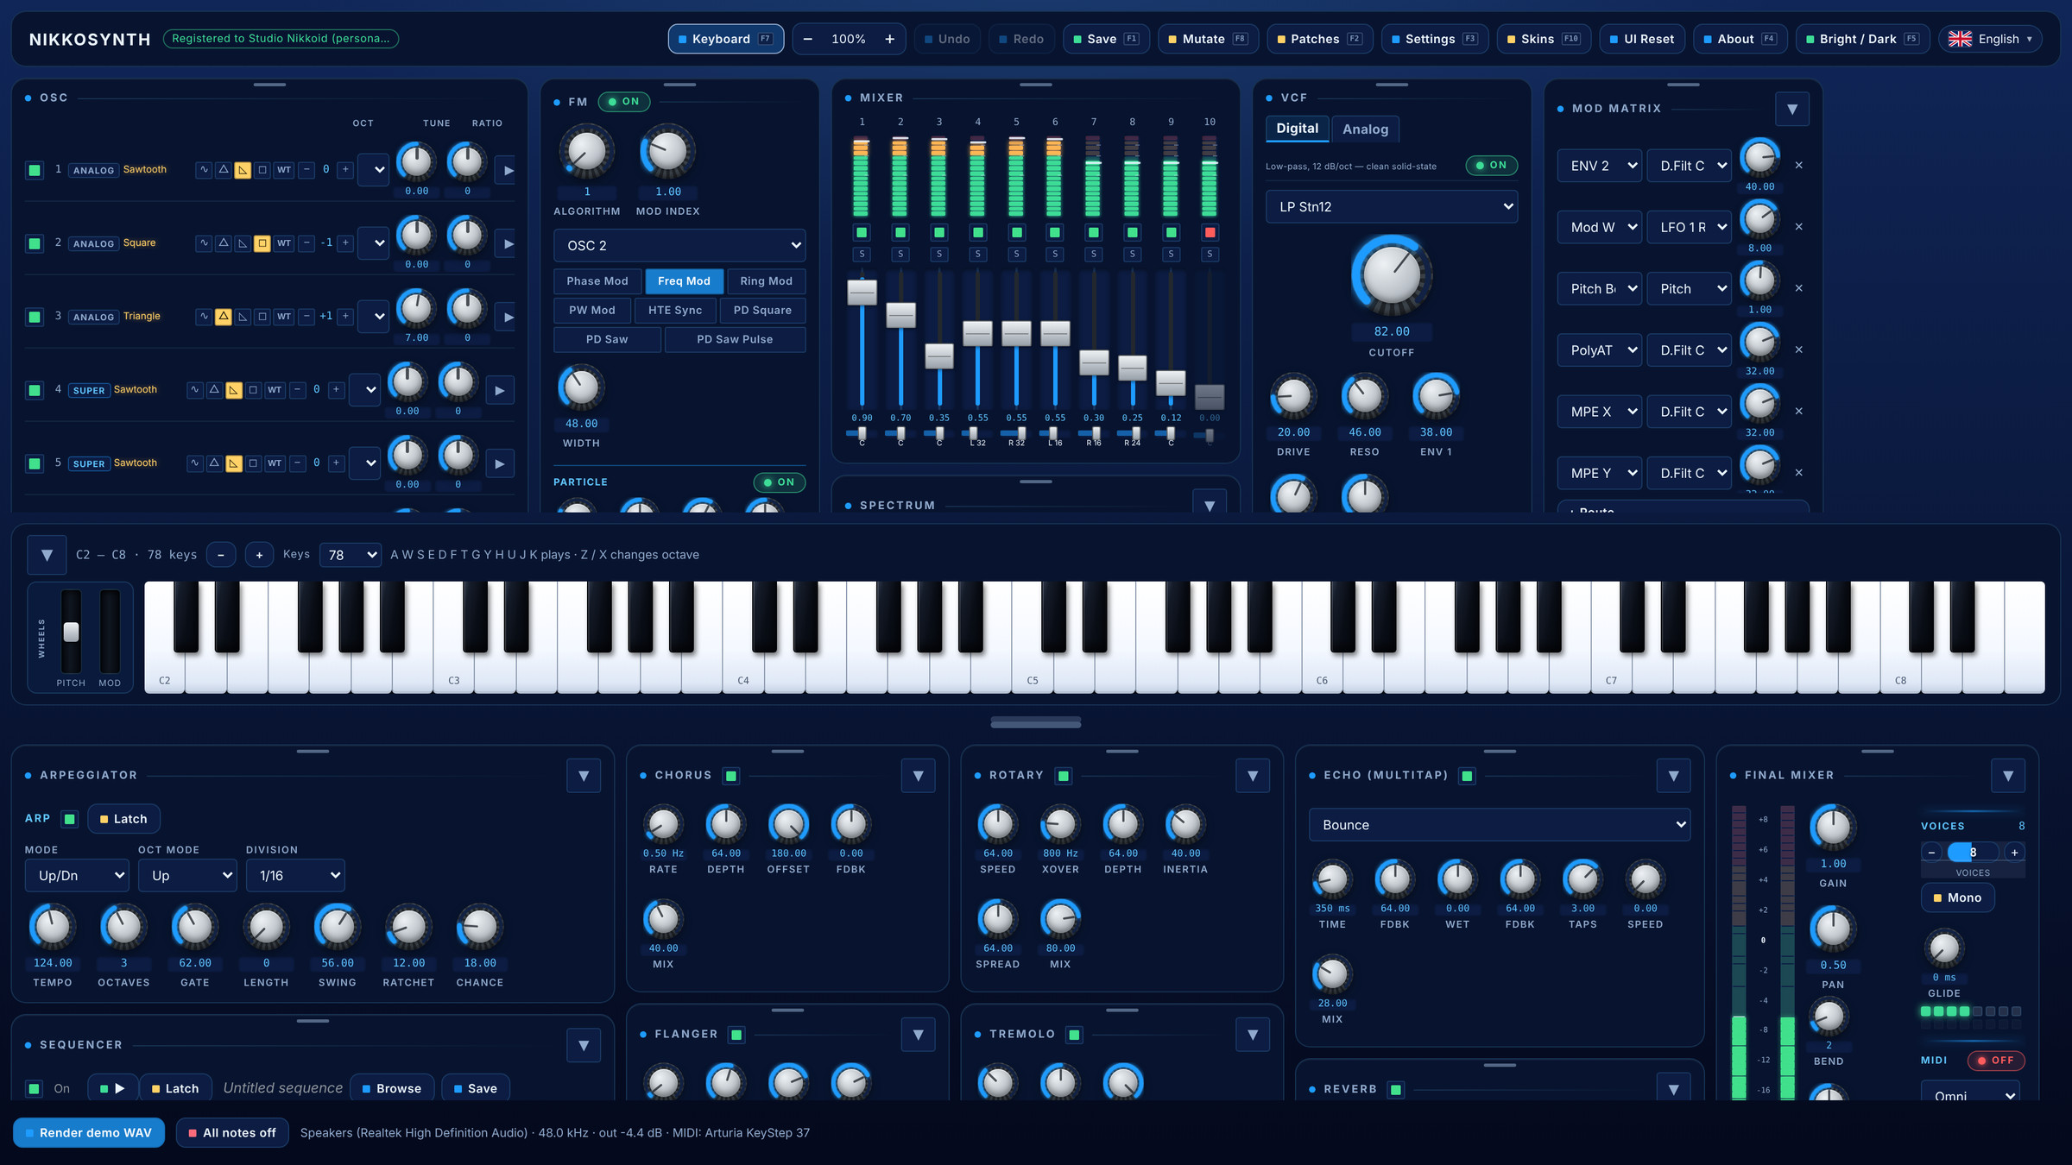
Ten oscillators · two filters in series · fifteen envelopes · five LFOs
a 32-slot matrix · arpeggiator and 8-track sequencer · twelve effects · 2,000 patches
NIKKOID LLC
Edition of 3 November 2026 · build 0.2.47 and the next release

CONTENTS

Contents
Part I — User Manual 3
1. Before you start 3
2. The interface 4
3. The oscillators 5
4. FM, Ring Modulator and Particle 11
5. The mixer and the spectrum 12
6. The filters 14
7. The VCA 16
8. The envelopes 17
9. The LFOs 19
10. The modulation matrix 20
11. The arpeggiator 21
12. The sequencer 21
13. The effects 24
14. The Final Mixer 27
15. The keyboard 28
16. Patches 28
17. Wavetables 30
18. Look, language and zoom 31
19. Keyboard shortcuts 33
20. Settings, licence and updates 33
21. Recipes 34
Part II — Technical Reference 36
22. Architecture 36
23. The signal path 36
24. The oscillator engine 37
25. The Super oscillator 38
26. Karplus-Strong and the DX7 39
27. Noise 39
28. The filters 39
29. Envelopes, LFOs and the matrix 40
30. Arpeggiator, sequencer and tuning 40
31. The effects 41
32. Files and formats 41
33. How this was verified 42
34. Why one instrument is enough 42
Appendix A — Parameter reference 43
A.1 Global conventions 43
A.2 Oscillators 43
A.3 Filters and VCA 43
A.4 Envelopes and LFOs 44
A.5 Matrix 44
A.6 Arpeggiator, sequencer and Final Mixer 44
A.7 Effects 45
Part III — Licence, Updates and Copyright 46
35. How the licence works 46
36. Updates 46
37. Credits and third-party material 46
38. Copyright and terms 47
PLAYING AND SHAPING SOUND

Part I — User Manual
Nikkosynth is a software instrument for people who write music and do not want to open three plug-ins to do it. Ten oscillators of six kinds, two filters in series, fifteen envelopes, five LFOs, a 32-slot modulation matrix, an arpeggiator, an eight-track step sequencer and twelve effects — in one window, on one panel, with two thousand patches ready to play.
This part is the practical manual: what each control does, why it is there, and how to get a sound you will keep. Part II explains how the instrument is built and what the algorithms actually are. Part III covers registration, licensing and copyright.
Most synthesizers make you choose between character and control. Nikkosynth was built on the conviction that you should not have to — and that once you have both in one instrument, you stop reaching for a second one.

How to read this manual
Parameter names appear in monospace or bold, exactly as the panel labels them. Values are given in the units the panel shows: 0…128 for most controls, ±64 for depths and amounts. Every figure is a capture of the real application at 200 %, cropped to the part of the panel the text is describing, so what you read and what you see are the same controls.
Boxes marked NOTE explain a design decision; boxes marked TIP are shortcuts that will save you time later.

1 Before you start
Nikkosynth runs as a desktop application. It opens an audio device on its own and plays immediately — there is no configuration step between launching it and hearing a note. If nothing is heard, the status line at the bottom of the window says why, and Chapter 20 covers the two settings that matter: the audio output and the MIDI input.

The first thirty seconds
- Launch Nikkosynth. A registration box appears if no licence is installed; Test for free closes it and the instrument is fully working — the only difference is the reminder in the title bar.
- Play your computer keyboard: A W S E D F T G Y H U J K are one octave, Z and X shift the octave. Or click the on-screen keys.
- Press Patches (F2), pick a folder, and click a patch: it loads and plays as you click.
- Turn a knob. Every knob responds while a note is held — you hear the change as you make it.
- Press Mutate (F8) a few times: each press is a slightly different take of the same sound.
That is the whole learning curve for playing. Everything else in this part is about shaping what you hear.
FIG 1.1 The whole instrument in one window, at its default layout: the sound-making plates on top (OSC, FM, Mixer, VCF, Mod Matrix…), the keyboard in the middle, and the Arpeggiator, Sequencer, effects and Final Mixer in the strip below.
NOTE Why the panel is laid out the way it is
Left to right, the top row follows the signal path: OSC → FM → Mixer → VCF/VCA → Mod Matrix/LFO → Envelopes. The strip under the keyboard is what happens to the summed sound: Arpeggiator and Sequencer, the effects in the order they run, and the Final Mixer at the far right. If you are ever lost, follow the sound: it starts at the left and reaches the output at the right.

2 The interface
One window holds the entire instrument. Nothing is hidden behind a tab that also hides a parameter you need: every module is a plate on the panel, and the panel reflows onto more rows rather than scrolling sideways when the window is narrow.

The title bar
The title bar carries the things you do once or occasionally rather than while playing. On the left, the name and the registration chip, which reads Registered to … once a licence is installed, or opens the registration box when it is not.
FIG 2.1 The left of the title bar: the instrument’s name and the licence chip.
On the right, the actions. Each button shows its function key in a small badge, so the shortcut is learnt by using the button.
FIG 2.2 Keyboard (show or hide the key bed), the zoom control, Undo and Redo, Save, Mutate and Patches.
FIG 2.3 Settings, Skins, UI Reset (every plate back to its factory place), About, Bright / Dark, and the language menu.

Plates: move, stack, fold
Every plate has a slim grip across its top edge. Drag it and the plate moves live among its neighbours. Drop it on the upper or lower half of another plate and it stacks in that plate’s column; drop it on a left or right edge and it becomes a column of its own. Pointing at the empty space under a column stacks the plate at its bottom. A plate stays in its own row — the top-row plates among themselves, the bottom strip among itself.
The chevron at the right of a plate’s title folds it to a single line. Plates never stretch to fill a row: each keeps its own size and only follows the zoom, and a column that would hang alone at the end of a line takes the rest of that line so no gap opens. The layout of each row is remembered.
TIP Getting the factory layout back
Double-click any grip to restore that row’s factory layout, or press UI Reset in the title bar to put every plate back, unfold everything and restore the divider’s height.

The divider
Between the keyboard and the bottom strip is a drag handle. Drag it to give the effects and the Final Mixer more or less room; the panel above takes whatever is left. Double-click it to return to the default height, and press Tab to swap the two extremes — the top filling the window, or the strip filling it.

Dialogs
Every dialog — the patch browser, the wavetable picker, Settings, Save — can be dragged by its title bar and is clamped so the bar never leaves the window; a double-click on the bar centres it again. Every dialog keeps its buttons on screen at any zoom, and Escape cancels the top-most one exactly as the close key does.

3 The oscillators
Ten oscillators, and they are not ten copies of the same thing. Each kind is fixed to its position, so a patch always knows what it is asking for.
OSCILLATOR | CHARACTER
OSC 1–3 · Analog | Sine, triangle, saw or square — band-limited, so they stay clean at the top of the keyboard — or any of the 451 built-in wavetables, plus your own.
OSC 4–6 · Super | Seven detuned copies of whatever waveform the oscillator carries. A super-sine or a super-wavetable is as valid as a super-saw.
OSC 7 · Karplus | A plucked string, or a struck bar or bowl. Four materials: Guitar, Piano, Metal, Glass.
OSC 8 · DX7 FM | Six-operator FM with the 32 classic algorithms, chosen from the diagram on its own page.
OSC 9–10 · Noise | Eight colours of noise: white, pink, brown, grey, blue, violet, velvet and crackle. A full channel with its own envelope.

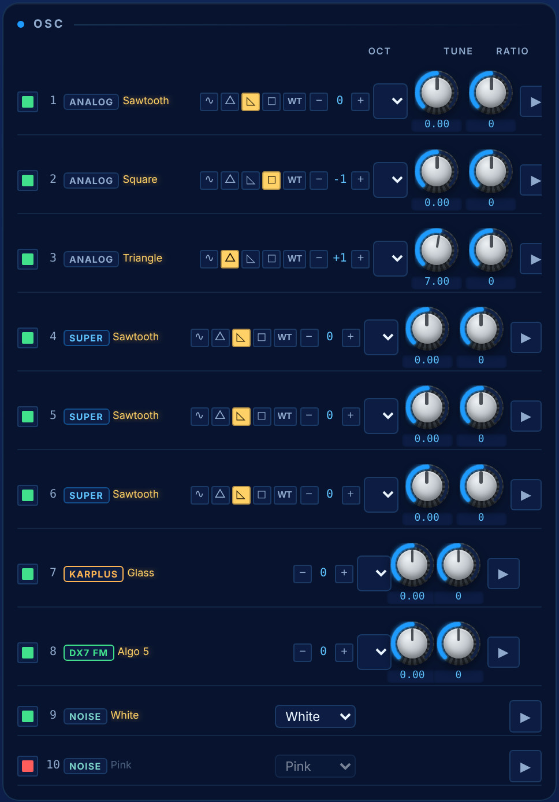
FIG 3.1 The OSC plate: one row per oscillator. Analog rows 1–3, Super rows 4–6, Karplus 7, DX7 8, and the two Noise rows at the bottom. An oscillator switched off (row 3 here, red key) is dimmed.

The row controls
Each row carries the controls you reach for constantly: the power key, the number and type, the current waveform’s name, the four waveform buttons and WT (the wavetable browser), the Oct stepper, the pitch mode (Semitone, Ratio, Frequency), Tune in cents and Ratio. The arrow key at the far right opens the oscillator’s own page.
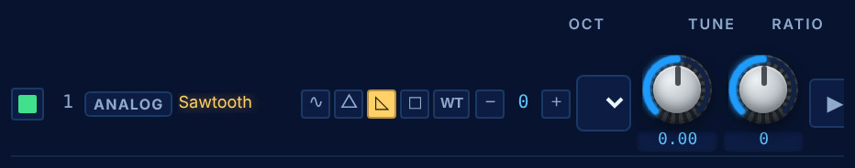
FIG 3.2 A single Analog row, zoomed: power key, type badge and wave name, the waveform buttons (saw selected), WT, the octave stepper, the pitch-mode menu, Tune, Ratio and the page key.
The power key and the mixer’s channel key are the same switch. Turn an oscillator off in either place and the other follows.

The oscillator page
Behind the arrow key is everything that would crowd the row: the level split, the envelope source, Invert, velocity and aftertouch depth, feedback, phase and keytrack — and for the special oscillators their own controls.
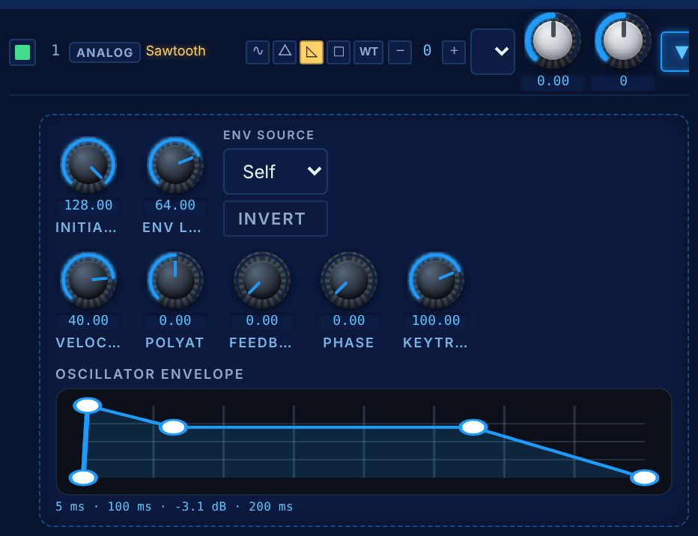
FIG 3.3 OSC 1’s page. Initial Level and ENV Level, ENV Source, Invert, Velocity, PolyAT, Feedback, Phase and Keytrack, then the oscillator’s own envelope as a curve you can drag.
The level comes in two halves. Initial Level is where the oscillator starts; ENV Level is how far an envelope moves it from there. ENV Source chooses that envelope: the oscillator’s own (Self), or one of the global ENV 1–3. When it is Self, the envelope is drawn underneath: drag a handle sideways to lengthen a stage, or the sustain handle up and down for the resting level. This is why every oscillator can breathe on its own schedule while the five global envelopes do the filters and the amplifier.
Invert flips the waveform’s polarity. Two detuned saws cancel against each other when one is inverted, which is how you get a hollow, nasal sound from a stack that would otherwise be fat.

The Super oscillator
Oscillators 4, 5 and 6 are a super stack: seven copies of the waveform, detuned along the curve measured from the original instrument, with a level balance between the centre voice and the six around it. Two controls do everything.
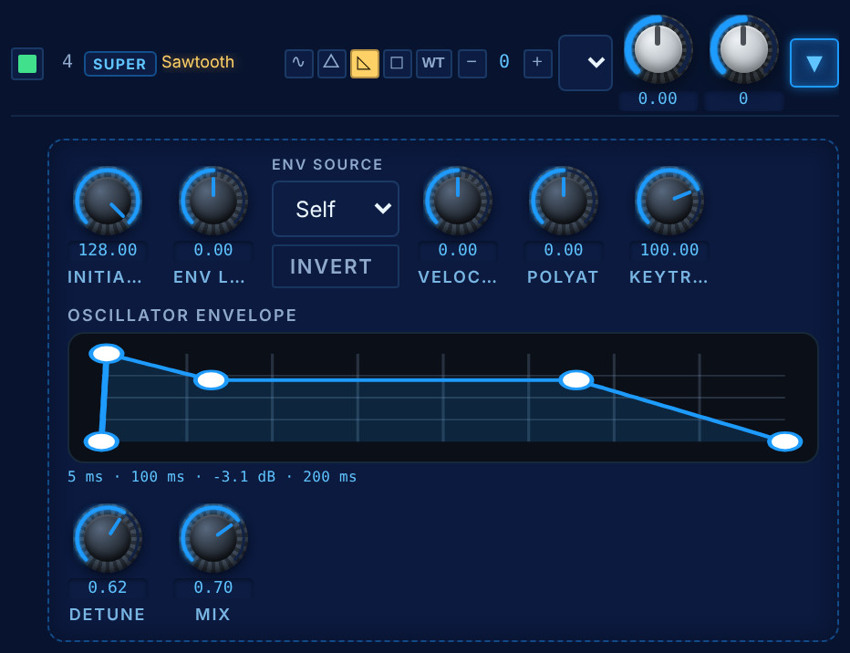
FIG 3.4 OSC 4’s page: the shared controls and envelope, then the two Super knobs, Detune and Mix.
CONTROL | WHAT IT DOES
Detune | How far apart the copies sit. Gentle for the first half of its travel and steep near the end, so the wide settings are a decision rather than an accident.
Mix | How much of the six detuned copies you hear against the centre voice. At the bottom it is one plain wave; at the top the copies dominate.

The Karplus oscillator
Oscillator 7 is a physical model, not a sample. Guitar and Piano are strings — the piano adds a hammer and a second, slightly detuned string. Metal and Glass are banks of struck bars and bowls whose partials are deliberately not harmonic. The four knobs are the instrument maker’s: how fast the highs die (Damping), how bright the strike is (Bright), how far the harmonics stretch (Disperse) and how long it rings (Decay).
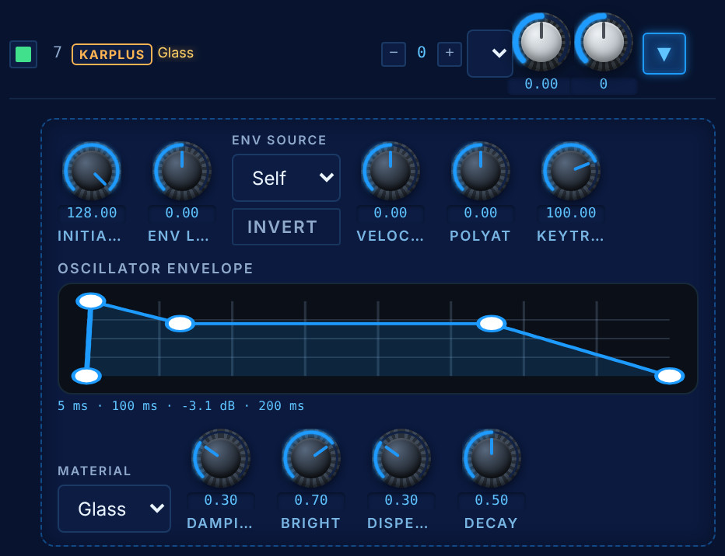
FIG 3.5 OSC 7’s page with the Glass material: Material, Damping, Bright, Disperse and Decay under the shared controls.

The DX7 oscillator
Oscillator 8 is six sine operators in the classic FM topologies. Its page shows the diagram of the algorithm in use, with ‹ › to step through all thirty-two; the diagram is drawn from the same routing table the sound uses. Carriers are filled, modulators are outlined. Feedback and Decay shape the whole, and R1…R6 tune each operator against the played note.
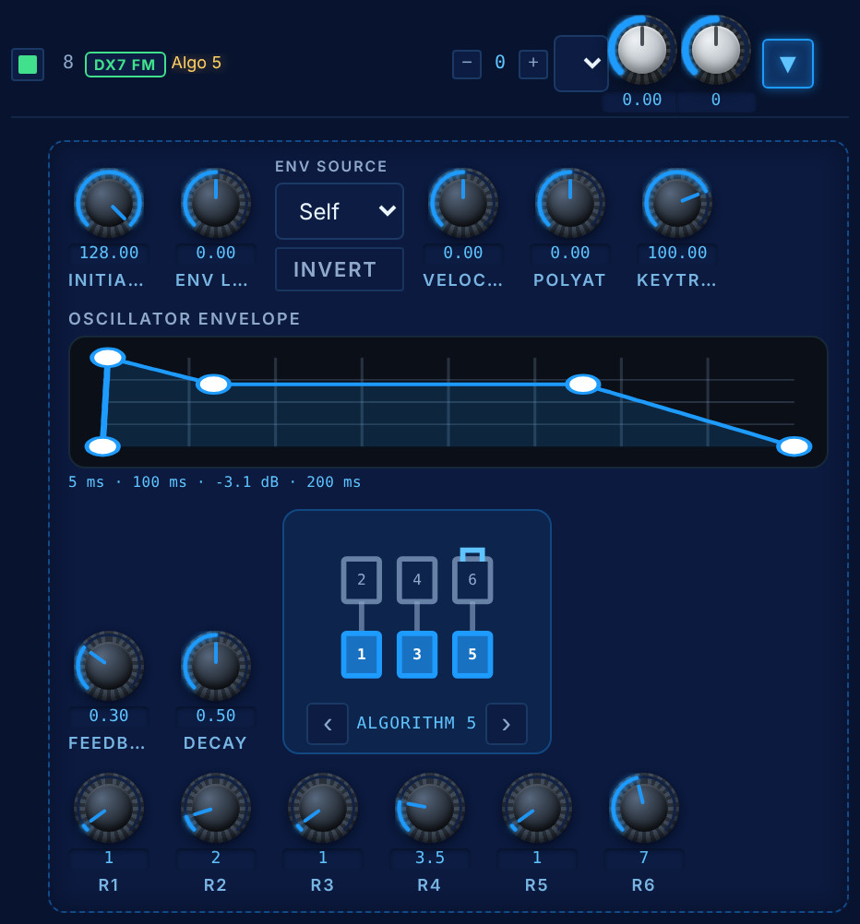
FIG 3.6 OSC 8’s page on algorithm 5: three carriers (1, 3, 5), each with its own modulator, and operator 6 feeding back on itself. Below, the six operator ratios.

The noise oscillators
Oscillators 9 and 10 are noise. They have no pitch, so instead of a waveform they choose a colour — white, pink, brown, grey, blue, violet, and two sparse ones, velvet and crackle. They are full oscillators in every other way: their own mixer strip, Initial and ENV Level, their own editable envelope, Invert, Velocity and PolyAT, and the matrix reaches them under the same names. Each voice has its own generator, so a chord gets a bed of noise rather than one shared hiss. The colours are trimmed to the same loudness, so changing colour changes the tone, not the level.
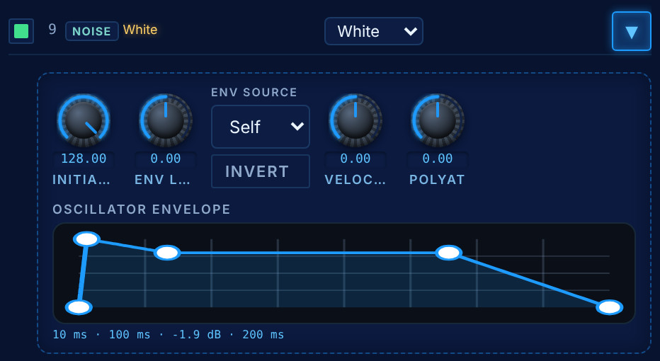
FIG 3.7 OSC 9, white noise, with its own envelope — short envelopes on the noise are how the kit’s snare wires and hat transients are made.

4 FM, Ring Modulator and Particle
The FM plate decides how the ordinary oscillators affect each other. Algorithm chooses one of 144 arrangements of carriers and modulators, and Mod Index sets how hard the modulators drive. Under them, pick an oscillator and choose its mode — Phase Mod, Freq Mod, Ring Mod, PW Mod, HTE Sync (hard sync), PD Square, PD Saw and PD Saw Pulse — and, in PW mode, its Width. The plate’s ON key switches all of it off at once; algorithm 1 has every oscillator as a carrier.

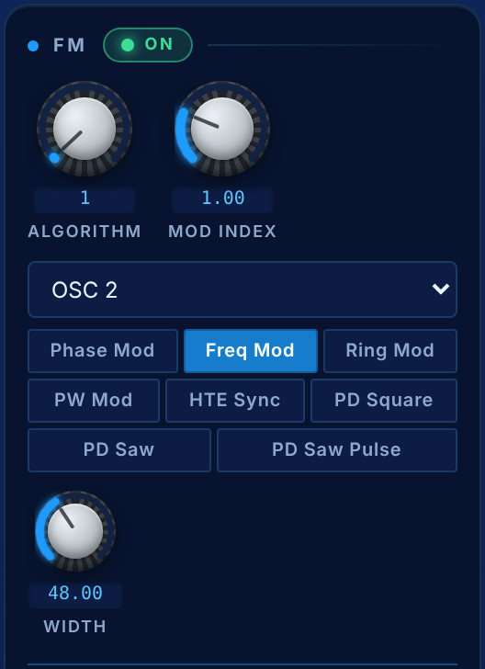 | 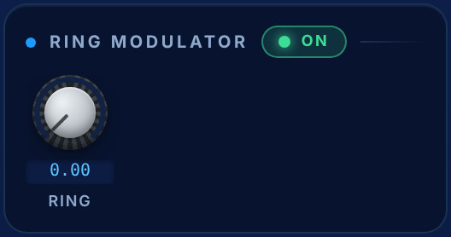
FIG 4.1 Left: Algorithm, Mod Index, the selected modulator and its mode. Right: the Ring Modulator, its own plate with its own key and depth.
The Ring Modulator multiplies the oscillators against each other for bell-like, metallic and clangorous tones; Ring is its depth, and it is a matrix destination, so it can creep in and out.
Particle, at the bottom of the FM plate, is a granular stage on the mixed oscillators: it chops the sound into grains and reassembles them. Mix, Size, Density, Spread and Pitch. Used lightly it thickens a pad; used fully it is a different instrument.
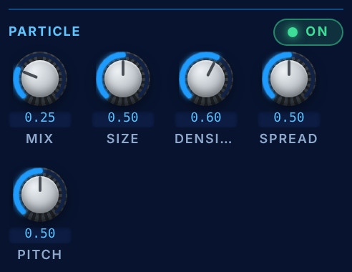
FIG 4.2 Particle, zoomed: its own on/off key, then Mix, Size, Density, Spread and Pitch.

5 The mixer and the spectrum
Ten channels, one per oscillator, built like a small desk: a meter, a power key, a solo key (S), a fader and a pan slider. The fader is the oscillator’s level in the mix; the pan places it. Solo is a listening aid — it never changes the stored switches, so switching it off restores the mix exactly as it was. Soloing silences the noise channels too.

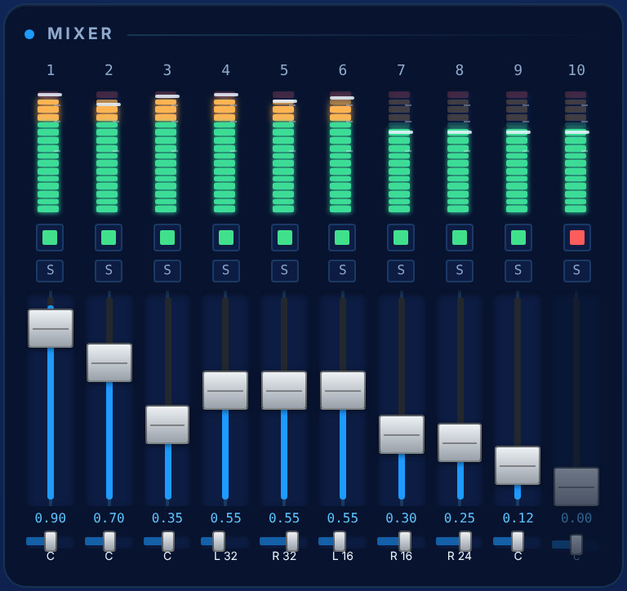 | 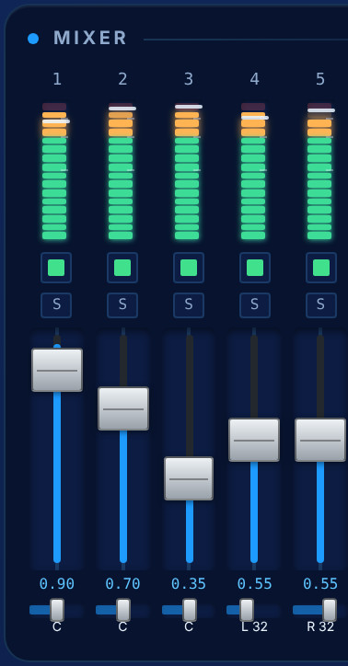
FIG 5.1 Left: the Mixer plate with a chord held. Right: the first strips zoomed — meter, power key, solo, fader with its value, and the pan slider with its position (C, L 32, R 32…).
The mixer also carries the Analog drive (the knob at the bottom of the FM plate): a soft saturation on the summed oscillators that adds the harmonics of an old machine. It is followed by an automatic make-up gain, so it adds colour without making the patch louder.
The Spectrum is its own plate under the mixer: a live view of the output: the analysis and the drawing style are chosen from its two menus, VU adds a level meter and PK holds the peaks. It is how you see that a patch is muddy before you decide which oscillator to pull down.
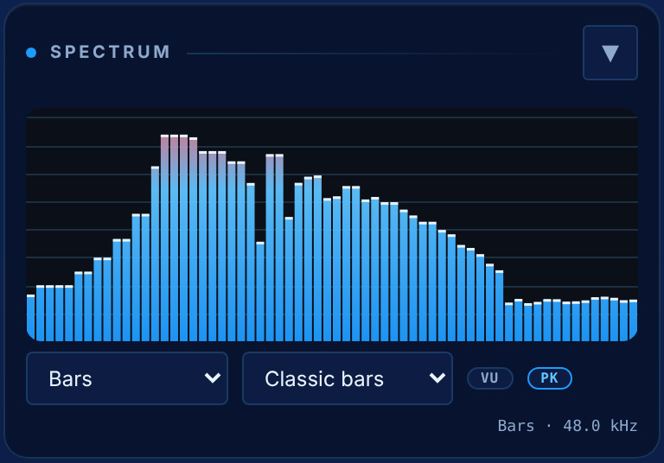
FIG 5.2 The Spectrum plate: a sawtooth chord, its harmonics falling away to the right. The menus choose the analysis and the drawing style.

6 The filters
Nikkosynth has two filters in series, and both are real. The Digital filter runs first and offers eighteen models; the Analog filter runs second and offers four circuits modelled from hardware. Each is a tab of the VCF plate with its own ON key, and the panel refuses to switch both off.

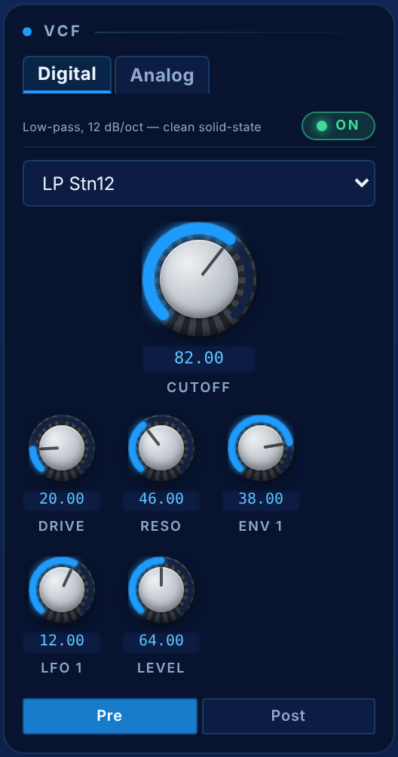 | 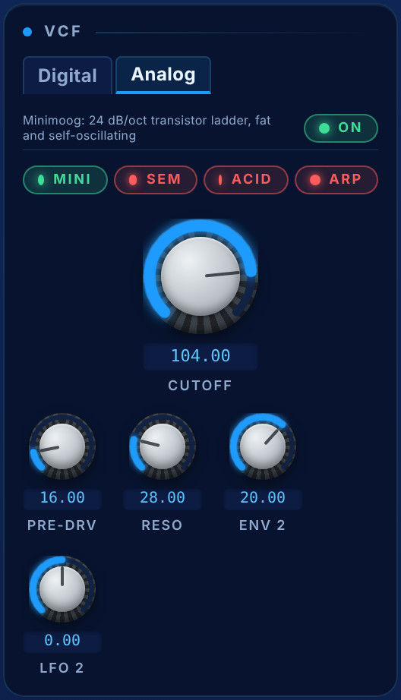
FIG 6.1 The VCF plate. Left, the Digital tab: the model menu, Cutoff, Drive/Morph, Reso, ENV 1, LFO 1, Level and Pre/Post drive. Right, the Analog tab: the four circuits as keys, Cutoff, Pre-Drive, Reso, ENV 2 and LFO 2.

The Digital filter
Eighteen models in five families: SEM morphing types that sweep low-pass → band-pass → high-pass (or through a notch); high-pass and band-pass models at several strengths; ten low-pass models from a gentle one-pole to a steep eight-pole; and a Vowel filter that sweeps across formants (A, E, I, O, U as the knob rises). One knob changes meaning with the type — Morph on SEM and Vowel, Drive on the others — and the panel relabels it. The line above the menu describes the model selected.
CONTROL | WHAT IT DOES
Cutoff | Where the filter acts, 0…128. The large knob, because it is the one you reach for most.
Reso | Emphasis at the cutoff. Many models self-oscillate at the top.
Drive / Morph | Input drive, or the SEM and Vowel morph.
ENV 1 · LFO 1 | Pre-wired depths: they work before you touch the matrix.
Level | The filter’s output, 64 = unity.
Pre · Post | Whether the drive acts before or after the filter.

The Analog filter
Four circuits, chosen with a row of keys: MINI (a Moog transistor ladder that loses bass as resonance rises and self-oscillates), SEM (an Oberheim state-variable that keeps its low end), ACID (a 303-style filter with squelchy resonance and envelope snap) and ARP (an OTA ladder, brighter and cleaner than the Moog). They are four topologies, not four names for one. Pre-Drive saturates the signal before it enters; Keytrack centres on C2 and defaults to 100 %.

7 The VCA
The VCA is the amplifier at the end of the voice and sits under the VCF, in the same column. Its key idea is that VCA Level is a ceiling: velocity, aftertouch and the LFO all work inside it, so a patch cannot clip into the effects however hard you play. The pills along the top show the signal path and light up the stages that are on; click one to jump to it.
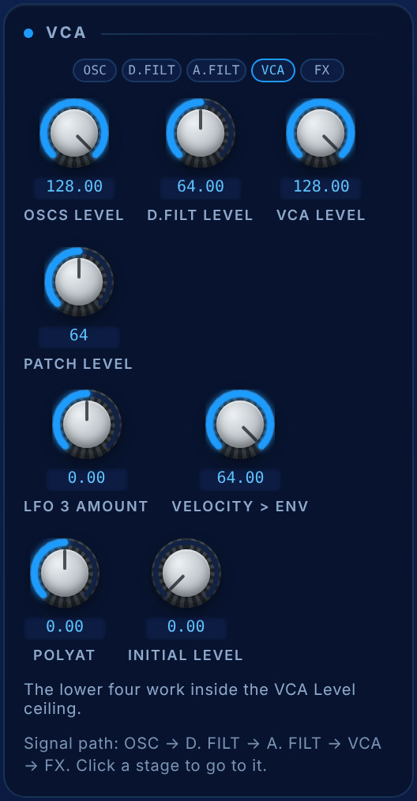
FIG 7.1 The VCA plate: OSCs Level, D.Filt Level, VCA Level, Patch Level, LFO 3 Amount, Velocity > ENV, PolyAT and Initial Level.
CONTROL | WHAT IT DOES
OSCs Level | One gain over all oscillators going into the filters.
D.Filt Level | The digital filter’s output level.
VCA Level | The amplitude ceiling.
Patch Level | The patch’s final trim; 64 is unity.
LFO 3 Amount | The pre-wired tremolo route.
Velocity > ENV | How much playing harder opens the amplifier. Zero means no velocity response.
PolyAT | Per-note pressure on the level.
Initial Level | Opens the VCA by hand, before any envelope.

8 The envelopes
Fifteen envelopes: five global ones on the Envelopes plate, and one inside each of the ten oscillators. They are the same kind of object, so this chapter applies to all of them. The global ones are pre-wired: ENV 1 shapes the amplifier and drives the digital filter through its ENV 1 knob; ENV 2 drives the analog filter through its ENV 2 knob, and a default matrix route also sends it to the digital cutoff. ENV 3, 4 and 5 are free for the matrix and for the oscillators’ ENV Source.

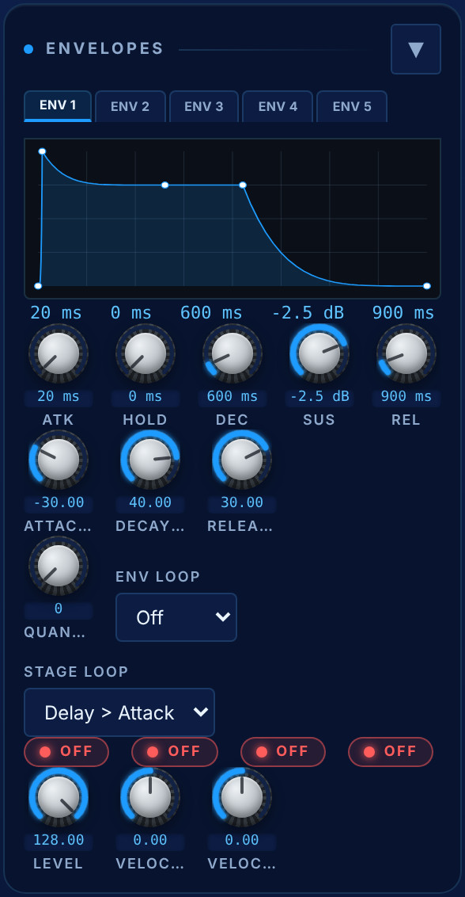 | 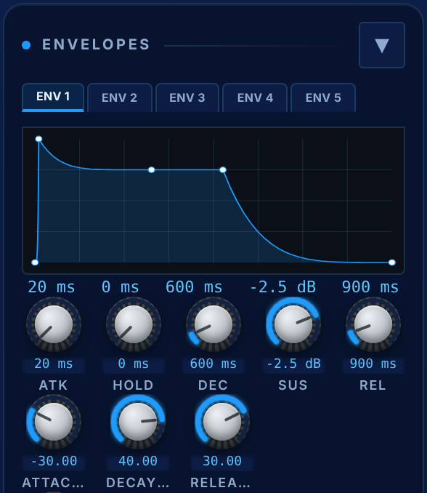
FIG 8.1 Left: the Envelopes plate — five tabs, the curve, the stage knobs, the three curve knobs, Quantize, the loops, Legato / Reset / Freerun / Invert, Level and velocity. Right: the curve and stage knobs zoomed.

The shape
It is a DAHDSR: Delay, Attack, Hold, Decay, Sustain, Release. The readout over the knobs follows the handles as you drag them on the curve; times are in milliseconds or seconds, sustain in decibels.

Curves
Attack, decay and release each have a curve, from exponential through linear to logarithmic. It is the difference between a snare that snaps and a pad that breathes, using the same times.
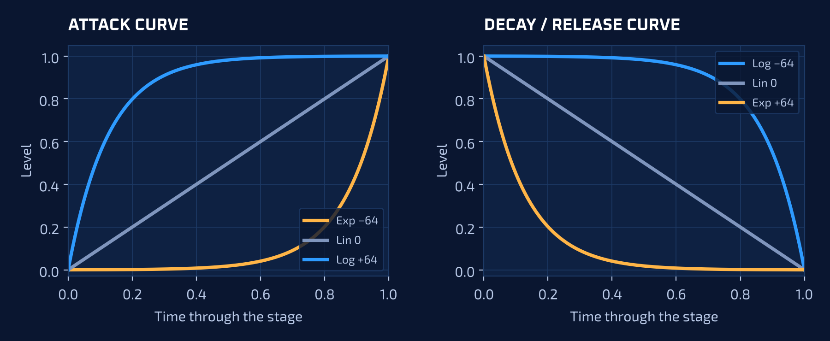
FIG 8.2 The attack curve (left) and the decay and release curve (right), drawn from the formula the engine runs.

Quantize, loops and stages
Quantize steps the envelope into a fixed number of levels — a smooth attack becomes a staircase. Env Loop repeats all or part of the envelope (2 to 50 times, or forever) and Stage Loop chooses what repeats: Delay > Attack, Delay > Hold or Delay > Decay. Looped, an envelope becomes a shape generator.

Legato, Reset, Freerun and Invert
Legato means the envelope does not restart while any note is held. Reset restarts it from zero on every retrigger. Freerun lets a released note finish its delay, attack, hold and decay before releasing.
Invert runs the envelope upside down wherever it modulates — the filters and every matrix route — so a sweep dips instead of rising, and the curve is drawn upside down to match. The volume envelope itself is never inverted, so a note still sounds and ends. Several Pure Analog pads, strings and brass (“Inverse”) are built on it.
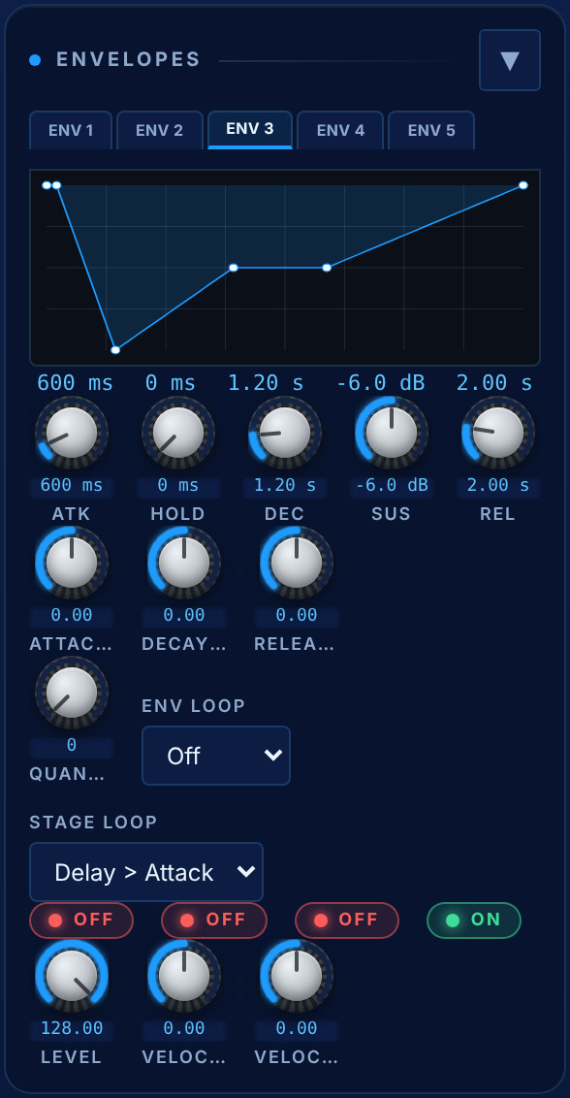
FIG 8.3 ENV 3 with Invert on (the green key at the bottom right): the same delay, attack, decay and release, drawn falling from the top because that is how it moves the filter.

Level and velocity
Level is a master depth for every route that uses this envelope. Velocity Curve and Velocity > ENV set how, and how much, playing harder deepens it.

9 The LFOs
Five low-frequency oscillators, each on its own tab with its own destination and amount. Eleven shapes: sine, triangle, saw up, saw down, square, two pulse widths, sample-and-hold, noise, random, and Step, a 64-step sequencer in disguise. The wave is drawn live at the bottom of the plate.

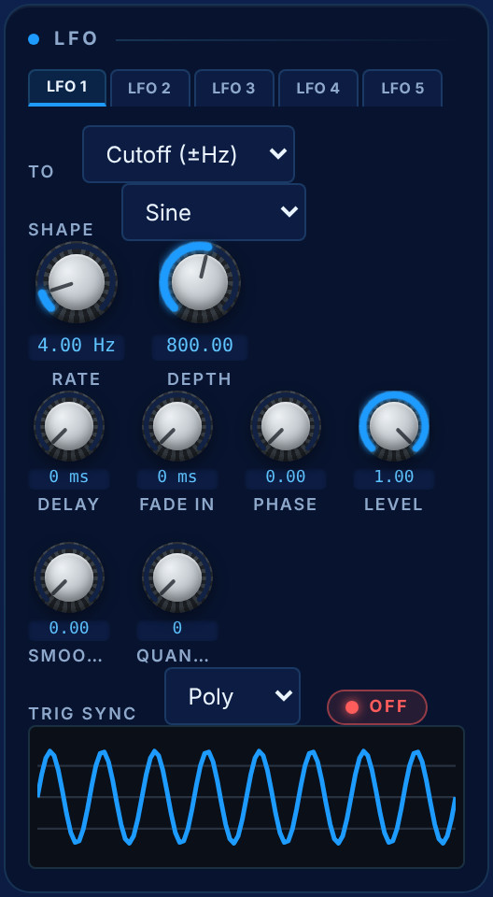 | 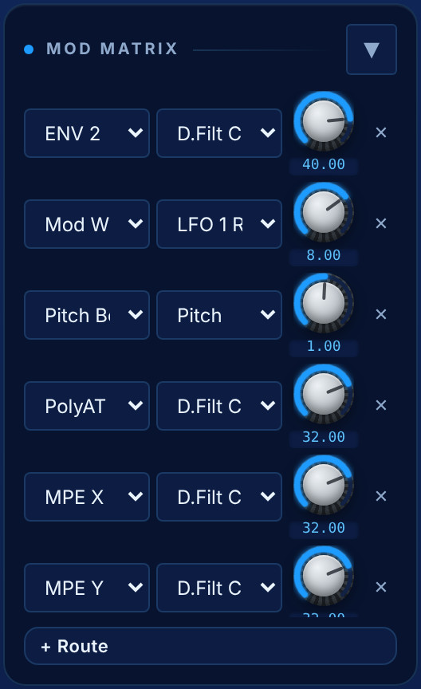
FIG 9.1 Left: the LFO plate — tabs, destination, Shape, Rate, Depth, Delay, Fade In, Phase, Level, Smooth, Quantize and Trig Sync. Right: the Mod Matrix with its default routes (Chapter 10).
CONTROL | WHAT IT DOES
Rate | A slow range for sweeps, a fast one for audio-rate movement, or BPM sync.
Delay · Fade In | Nothing for a while, then the movement arrives gradually: vibrato that sounds played rather than switched on.
Phase | Where the cycle starts. Every note starts at the Phase plus a random offset, so a moving sound never begins the same way twice.
Trig Sync | Poly gives every note its own LFO, Single shares one, Off never restarts it.
Smooth · Quantize | Glide between values, or snap to steps.
Level | One depth for every route that uses this LFO.

The three most useful LFOs are pre-wired: LFO 1 → digital filter, LFO 2 → analog filter, LFO 3 → amplifier.

10 The modulation matrix
Thirty-two routes, each a source, a destination and a signed depth. It is where the envelopes, the LFOs, the wheels, the keyboard, the sequencer and anything arriving over MIDI can reach anywhere. + Route adds a row; × removes one.

Sources
The five global envelopes and the ten oscillator envelopes; five LFOs and a unipolar version of each (the + variants); velocity, note number, keytrack, poly and channel aftertouch, mod wheel, pitch bend, expression and sustain pedals; MPE X, MPE Y, MPE Y+; any MIDI CC 0–127; a constant; and Seq Mod, the sequencer’s per-step Mod lane.

Destinations
Every oscillator’s initial level, envelope level, ratio, feedback, pulse width and (OSC 4–6) Super detune; the noise levels; the ring modulator’s depth; both filters’ cutoff, resonance, morph or drive, envelope and LFO amounts and levels; the VCA; each LFO’s rate and level; the output level, the pan and the wavetable scan position.

The default routing
- ENV 2 → digital filter cutoff — the filter envelope, working before you touch anything.
- Mod Wheel → LFO 1 rate — the wheel brings in vibrato.
- Pitch Bend → Pitch — by the range set in the Final Mixer.
- PolyAT, MPE X and MPE Y → digital filter cutoff — press harder, or lean on the note, and the tone opens.
Those routes are why a patch responds under the fingers even if you never open the matrix. They are added once to an older patch and never forced back, so a route you delete stays deleted.

11 The arpeggiator
The arpeggiator has its own clock, so it runs without a host. Mode chooses the pattern (Up, Down, Up/Dn, Up&Dn, Order, random, chord and phrase patterns), Oct Mode how the range expands, Division one of eighteen note values; then Tempo, Octaves (1–6), Gate, Length, Swing, Ratchet and Chance. Latch holds the chord after you let go.
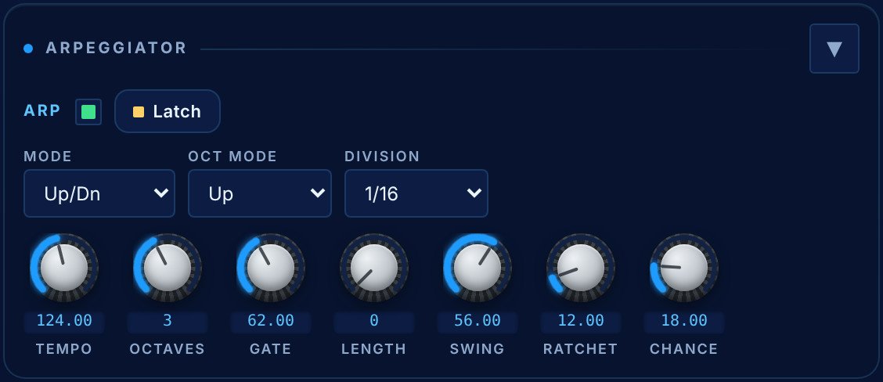
FIG 11.1 The Arpeggiator plate: the ARP key, Latch, Mode, Oct Mode and Division, then Tempo, Octaves, Gate, Length, Swing, Ratchet and Chance.
Ratchet repeats a step within itself and Chance decides how often a step fires. Set Chance low and the same chord never comes back the same way twice.

12 The sequencer
The Sequencer is its own plate, under the Arpeggiator. It has eight tracks, each with its own length up to 64 steps, so tracks of different lengths drift against each other (polymeter). When it is on it replaces the arpeggio, and the key you hold transposes the whole pattern.
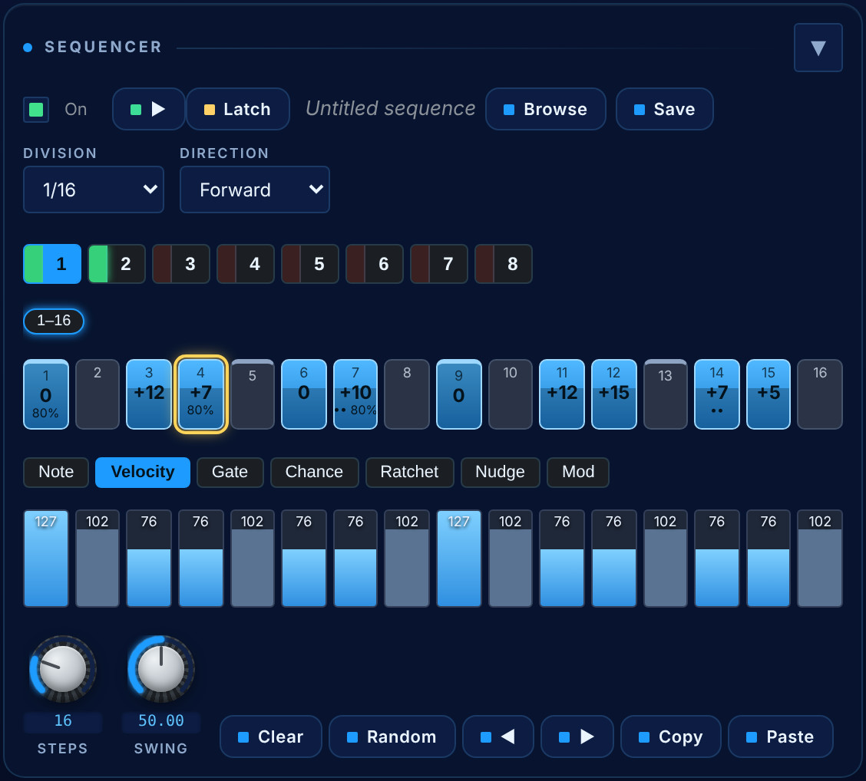
FIG 12.1 The Sequencer plate: On, the transport (Play / Stop), Latch, the current sequence’s name with Browse and Save, Division and Direction, the eight track keys, the sixteen-step page, the lane tabs and the lane itself, then Steps, Swing and the tools.

Steps and lanes
Sixteen steps are on screen at a time, with pages for longer tracks; beats are marked, unused steps are visibly absent, and a playhead follows the music. Click a step to arm it. Each step has seven lanes, chosen with the tabs under the grid and drawn by dragging across the bars: Note, Velocity, Gate, Chance, Ratchet, Nudge (micro-timing) and Mod, a per-step value the matrix routes anywhere as Seq Mod.
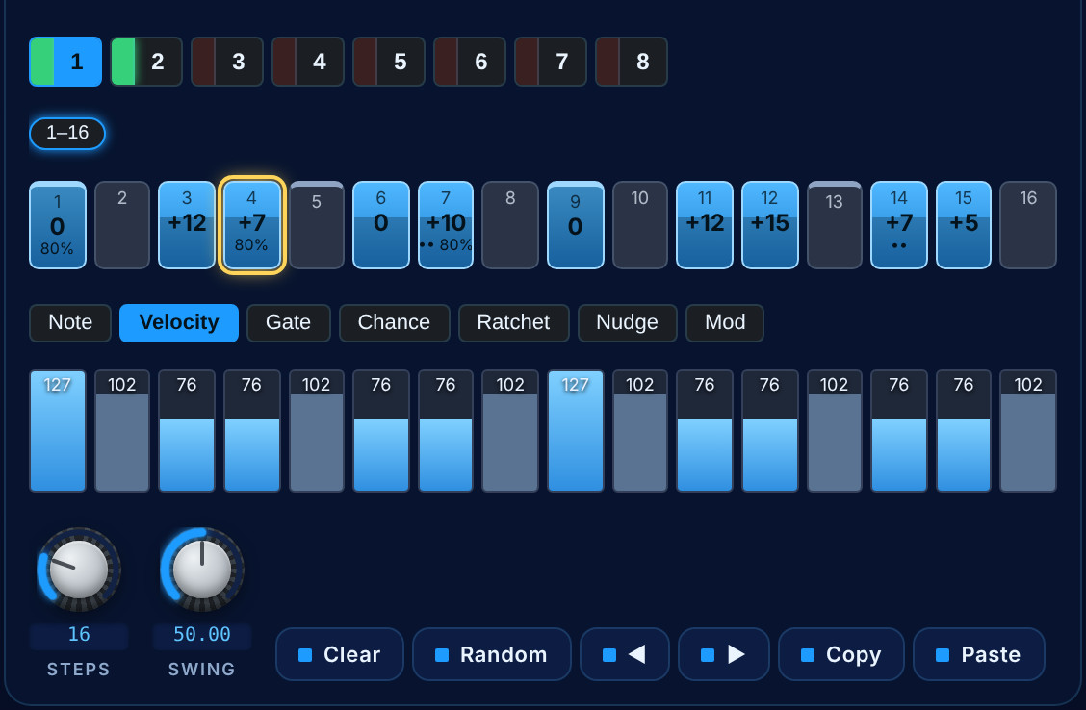
FIG 12.2 The step grid and the Velocity lane, zoomed: accents on the beats. The highlighted step is the one being edited.
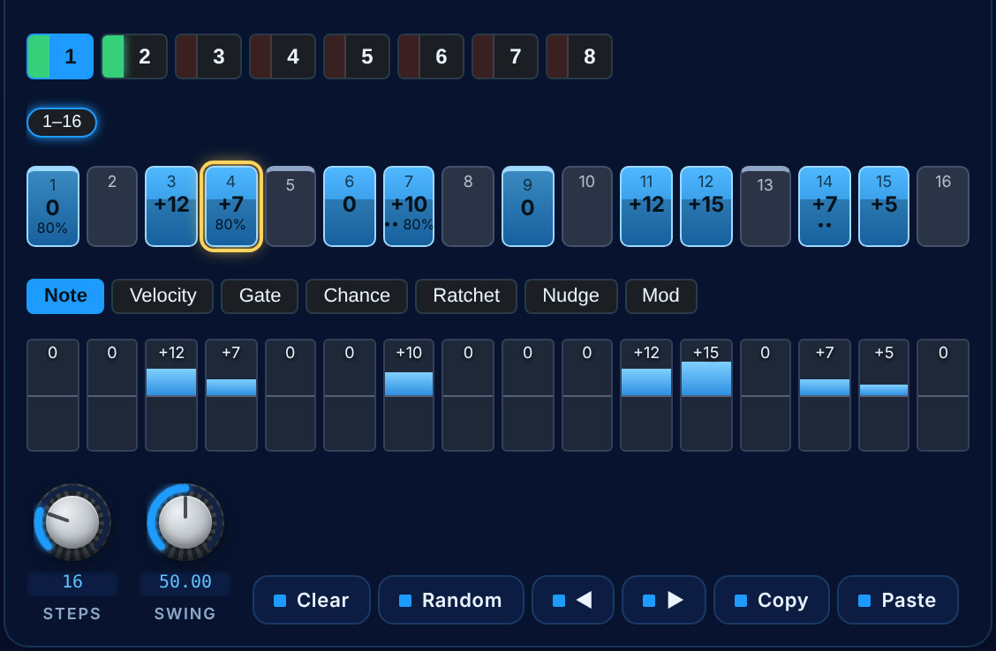
FIG 12.3 The Note lane: the transpositions that make the line (+12, +7, +10, +15…).

Clock, transport and tools
The sequencer has its own Division, Swing and Direction (forward, backward, ping-pong, random); only the tempo is shared with the arpeggiator. Play / Stop plays the pattern with no key held, and Latch keeps it running after the keys are lifted — play is never saved in a patch, so loading one never starts playing. The tools at the bottom: Clear, Random (a rhythm on a minor pentatonic), shift left and right, Copy and Paste a track.

The sequence library
Browse opens 500 factory sequences in twenty genres, from Techno, House and Trance to Hip-Hop, Synthwave, Ambient and Cinematic, each written from that style’s own division, swing, scale and kind of line. Click a sequence to audition it live, Preview to hold a key so it plays hands-free, then Keep or Cancel. Save stores your own as a User Seq under a genre of your choice; factory sequences cannot be renamed or deleted.
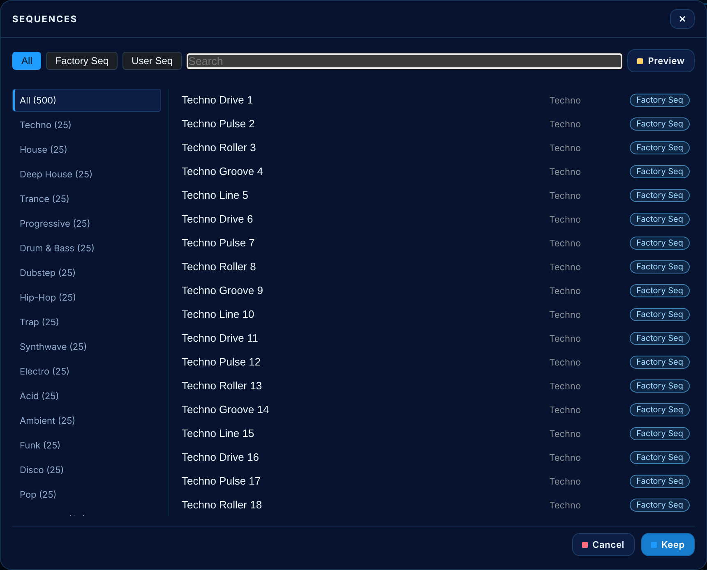
FIG 12.4 The sequence browser: genres on the left with their counts, All / Factory Seq / User Seq filters and a search, and the sequences with their tags.

13 The effects
Twelve effects, each its own plate with its title first and its bypass key in the title row — green when on, red when off — so one can be taken out of the path without losing its settings. They run in the order of the strip.
GROUP | EFFECTS
Pre-FX | Chorus, Flanger, Phaser (2–12 all-pass stages swept between 160 Hz and 5.2 kHz), Distortion and Lo-Fi (sample-rate and bit-depth reduction with a tone filter — the aliasing is the point).
Modulation | Rotary (a rotating speaker with crossover, inertia and spread), Tremolo, Vibrato and Wah (auto or pedal).
Space | Echo — up to four taps, Bounce or Sweep — Reverb — Room, Hall, Plate, Chamber and Shimmer — and a five-band EQ.

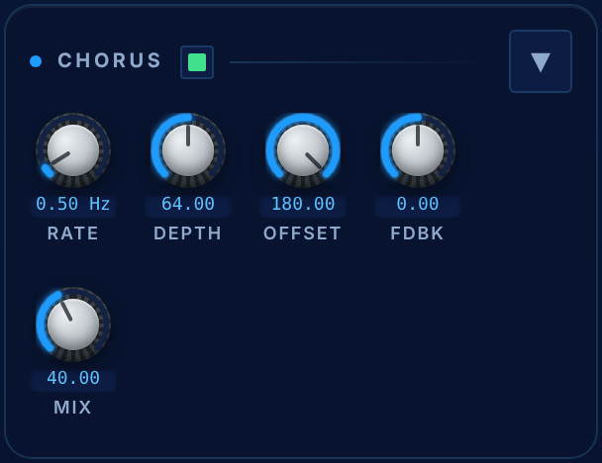 | 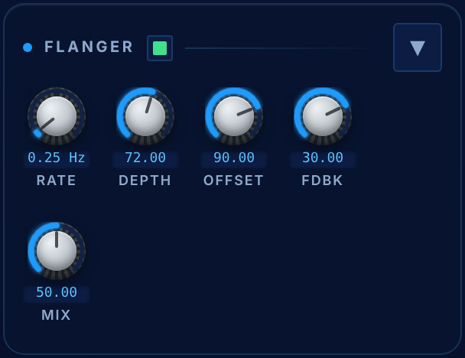
FIG 13.1 Chorus and Flanger: Rate, Depth, stereo Offset, Feedback and Mix.

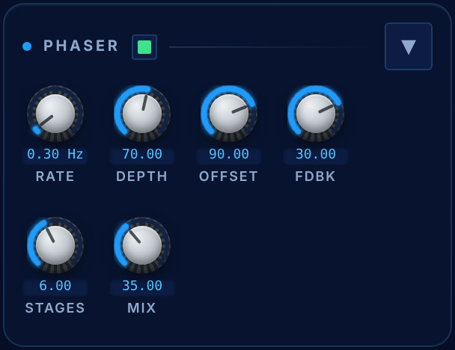 | 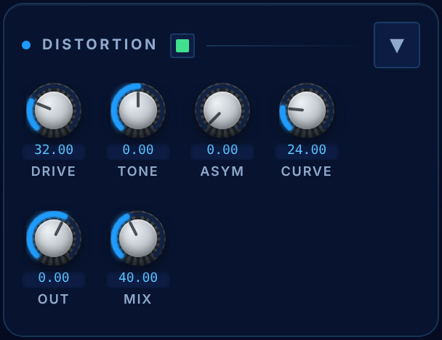
FIG 13.2 The Phaser (Rate, Depth, Offset, Feedback, Stages, Mix) and Distortion (Drive, Tone, Asym, Curve, Out, Mix).

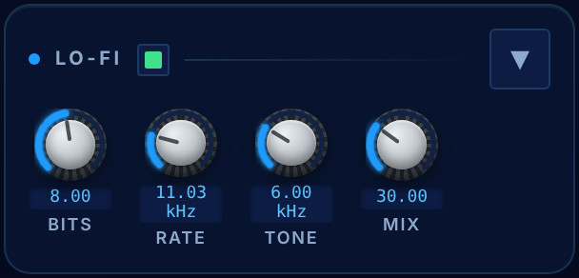 | 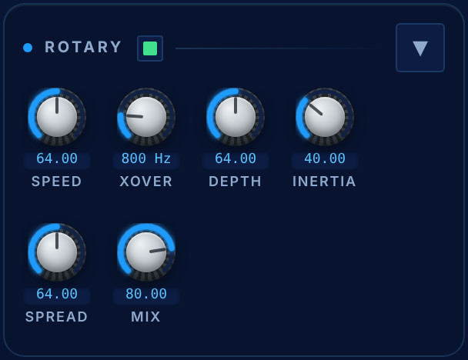
FIG 13.3 Lo-Fi (Bits, Rate, Tone, Mix) and Rotary (Speed, Crossover, Depth, Inertia, Spread, Mix).

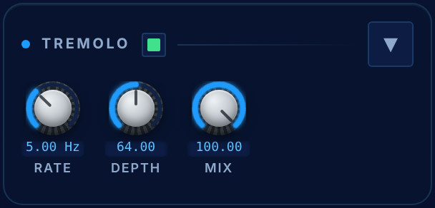 | 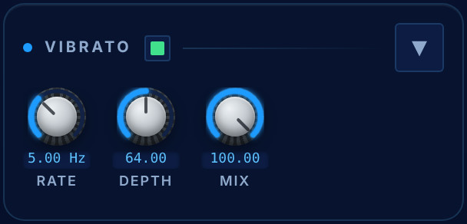
FIG 13.4 Tremolo and Vibrato: Rate, Depth and Mix.

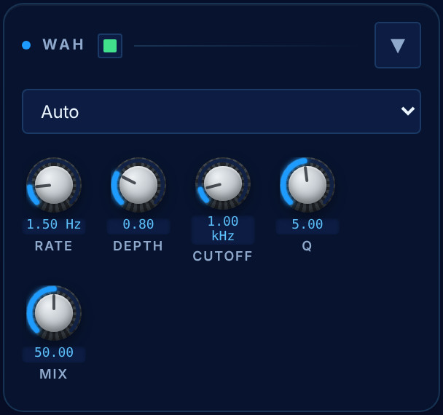 | 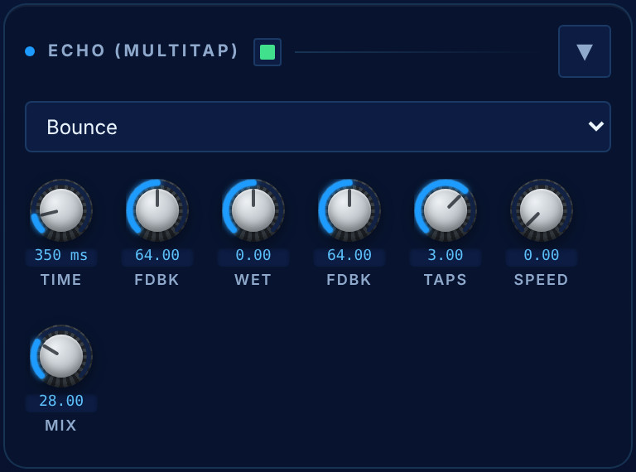
FIG 13.5 The Wah (mode, Rate, Depth, Cutoff, Q, Mix) and the Echo: the stereo behaviour (Bounce here), Time, Feedback, Wet, Feedback Tone, Taps, Speed and Mix.

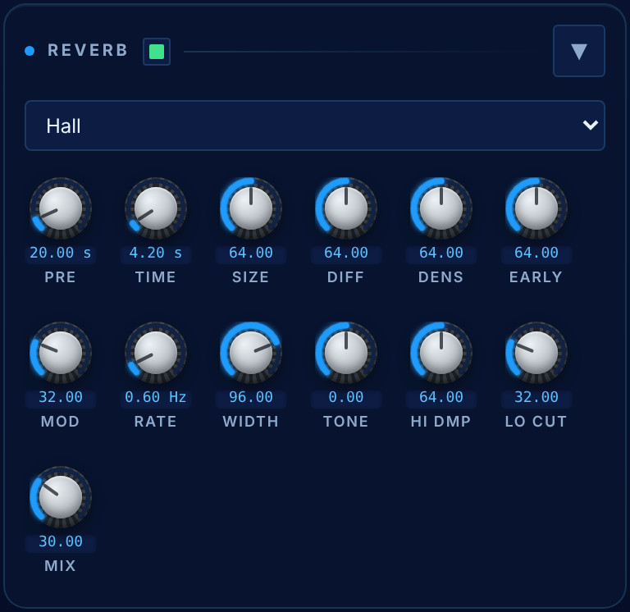 | 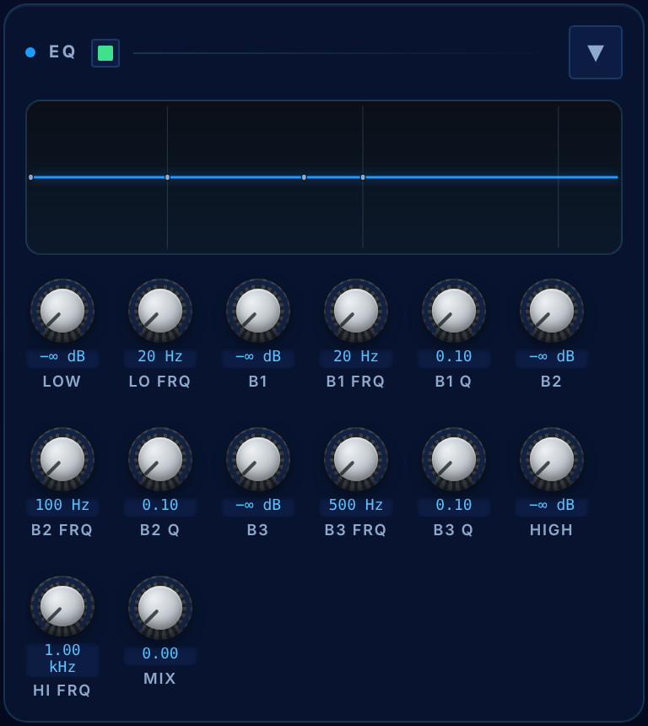
FIG 13.6 Left: the Reverb — the type, then Pre-delay, Time, Size, Diffusion, Density, Early, Mod, Rate, Width, Tone, High Damp, Low Cut and Mix. Right: the EQ — low shelf, three peaks and a high shelf; the response curve is drawn from the same coefficients the engine runs, and its handles can be dragged (touching the curve switches the EQ on).
NOTE Echo and reverb are sends
Turning up the reverb or the echo adds the tail; it does not turn the dry patch down. The character effects (chorus, distortion…) stay crossfades, because replacing part of the dry signal is their effect.

14 The Final Mixer
The last plate before the audio device. On the left a stereo VU ladder reading the post-limiter output. Then Gain, Pan, Bend (the pitch-wheel range in semitones) and Global Pitch (±24 semitones for the whole patch).
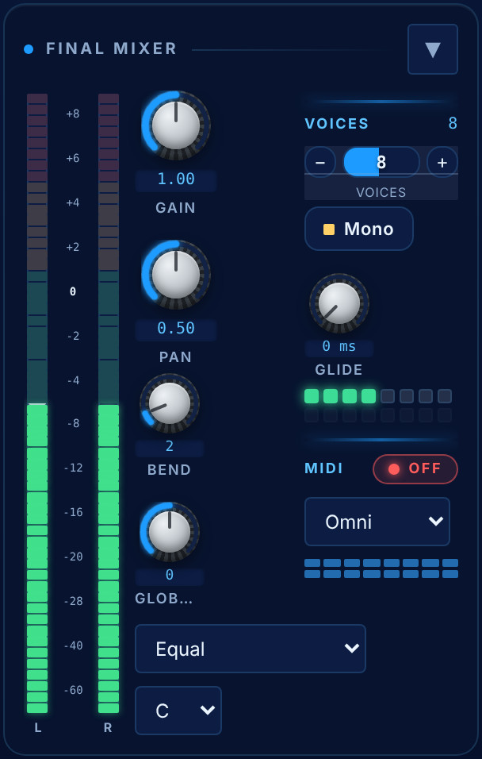
FIG 14.1 The Final Mixer: the stereo meter; Gain, Pan, Bend and Global Pitch; Voices with its LEDs, Mono and Glide; MIDI receive mode and channel lamps; and Microtuning with its root.

Voices, Mono and Glide
Voices sets the polyphony from 1 to 16; the LEDs light as each voice plays, so you can see the round-robin working. Mono is a true mono mode — one note, last-note priority, legato: a key played while another is held moves the note without a new attack, and lifting it returns to the key still held. Glide is portamento, in mono and in poly. Every mono lead and bass in the bank plays legato with a short glide.

MIDI
The receive mode — Omni, Unison or one of sixteen channels — with a lamp for each channel, and the MPE key, which gives every note its own channel so its pitch bend, slide and pressure are its own.

Microtuning
A per-patch tuning applied to every note at note-on, so keys, arpeggiator, sequencer and MPE all follow it: Equal, Just (5-limit), Pythagorean, ¼-comma Meantone, Werckmeister III and Rast (quarter-tone), each with a selectable root. Custom starts from whatever was playing and offers twelve ±100-cent knobs labelled with the notes they fall on. A key always stays the same note — the tuning only moves it by less than a semitone.
A lookahead limiter and a DC blocker sit across the master. Neither is there to make the instrument loud: they keep any patch from clipping the output however many oscillators and effects are piled up.

15 The keyboard
The on-screen keyboard defaults to 78 keys and can be set from 37 to 88 in the Keys menu on its header, with − / + to move the range. Pitch and mod wheels sit at its left, where a keyboard’s are: the pitch wheel springs back to centre, the mod wheel stays where you leave it.
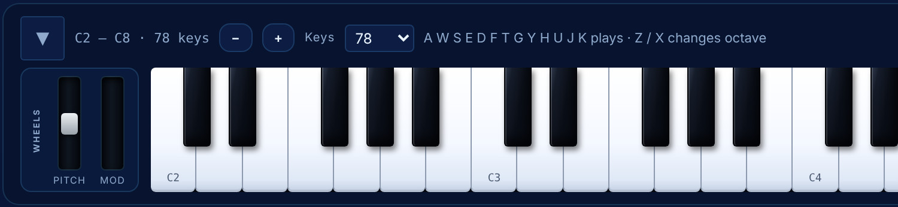
FIG 15.1 The keyboard’s left end, zoomed: the header with the range, the − / + steppers and the Keys menu, the wheels, and the first two octaves.
Keys are velocity-sensitive to where you click — nearer the front is softer — and pressing deeper while holding sends aftertouch, the same polyphonic aftertouch the matrix and the VCA read. Keyboard (F7) folds the key bed away; the computer keys still play.
From a MIDI keyboard, Nikkosynth accepts notes, pitch bend, mod wheel, mono and polyphonic aftertouch, sustain and expression pedals, and MPE.

16 Patches
Two thousand factory patches ship with the instrument, in folders: Arp, Bass, Bells, Brass, Cinematic, Ambient, Drone, Evolving, Keys, Lead, Organ, Pad, Perc, Pluck, SoundFX, Strings, Vocal, the generated families Complex, Noisy and Super, and Pure Analog.
- The authored seeds are hand-written: each is a sentence describing the sound and the choices that make it. A thousand patches are derived from them at every oscillator count from one to eight, plus four hundred pairs layered into one.
- Complex uses all eight tone oscillators, three effects or more, ring modulation and all 144 FM algorithms; Noisy carries a band of the sound on the noise pair; Super is JP-8080 territory on OSC 4–6.
- SoundFX is a game-audio kit — Explosion, Laser Beam, Riser, Coin, Power Up, Teleport, Thunder… — with 200 GFX variations, from XS to Max.
- Pure Analog (200 patches) is made the way a Minimoog, an SEM or an ARP 2600 made them: three oscillators on classic waves, the analog filter alone with its own envelope, analog drive on, and no effects. Twelve styles — Bass, Lead, Brass, Strings, Pad, Keys, Organ, Stab, Pluck, Arp, Sequence and Drums — as sub-folders, with the four circuits rotating through each.

The browser
Patches (F2) opens the browser: folders on the left with their counts (sub-folders indented under their parent; clicking the parent shows all of them), patches in the middle with a search box, sortable columns and a star for favourites, and Details on the right. Clicking a patch loads and plays it; Apply keeps it and Cancel puts back what you were playing. From the keyboard, ↑ / ↓ move to the patch above or below and load it, so a folder can be auditioned without the mouse, and ← / → step through the folders.
The Details panel describes the patch you clicked: its name, the soundbank it came with and that bank's cover, its author, whether it is one of your favourites (click to change it), and what it uses — the oscillators that are heard, the filters, FM and the ring modulator, the effects, the arpeggiator, the sequencer, and the LFOs and matrix routes that move it — with a complexity rating from one to five stars.
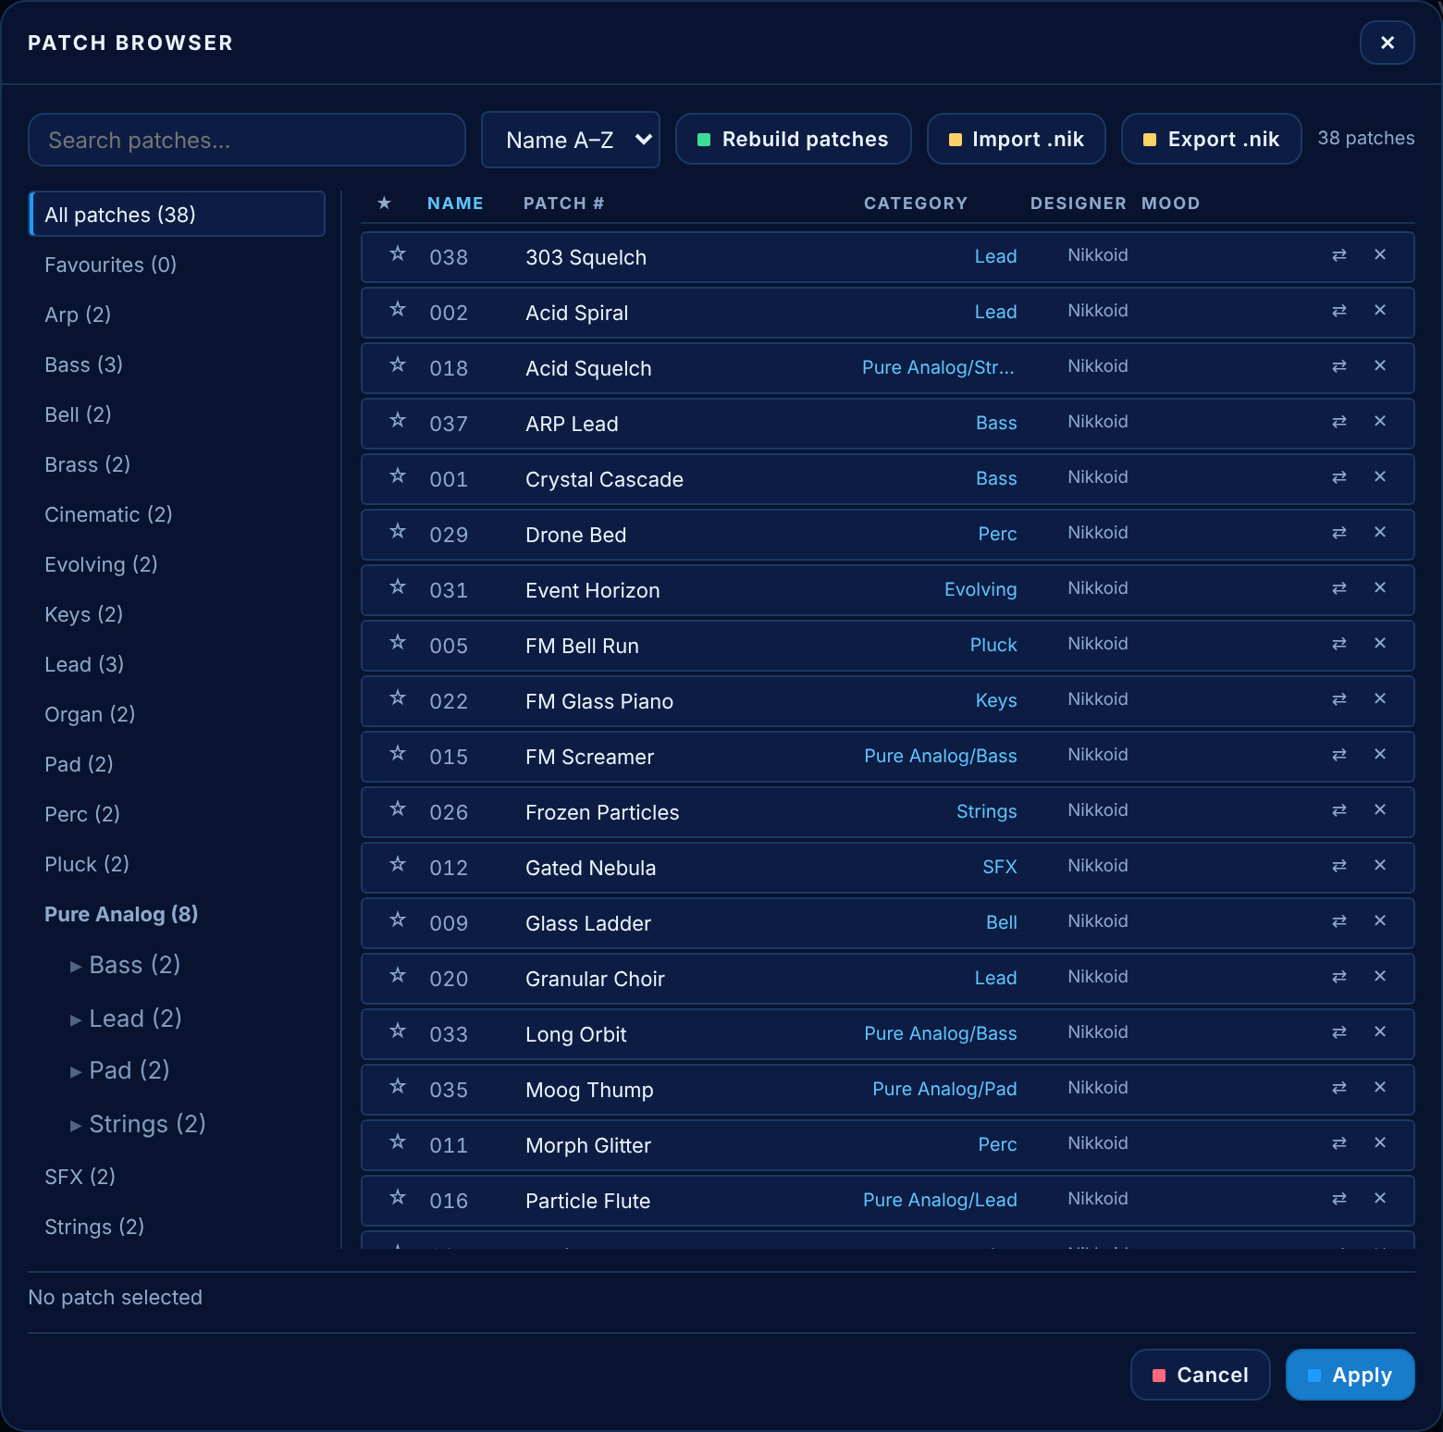
FIG 16.1 The patch browser: All patches, Favourites, the factory folders and Pure Analog with its styles; the rows with the favourite star, number, name, category, designer and mood; Rebuild patches, Import .nik and Export .nik at the top.

Saving
Save (F1) writes the current patch with a name, a user folder and a mood. User patches live only under Users, in folders you name, so they never mix with the factory sounds; the dialog lists your folders and can create a new one. Patches are .nikkosynth files — plain text, one setting per line — so they can be read, diffed and version-controlled.
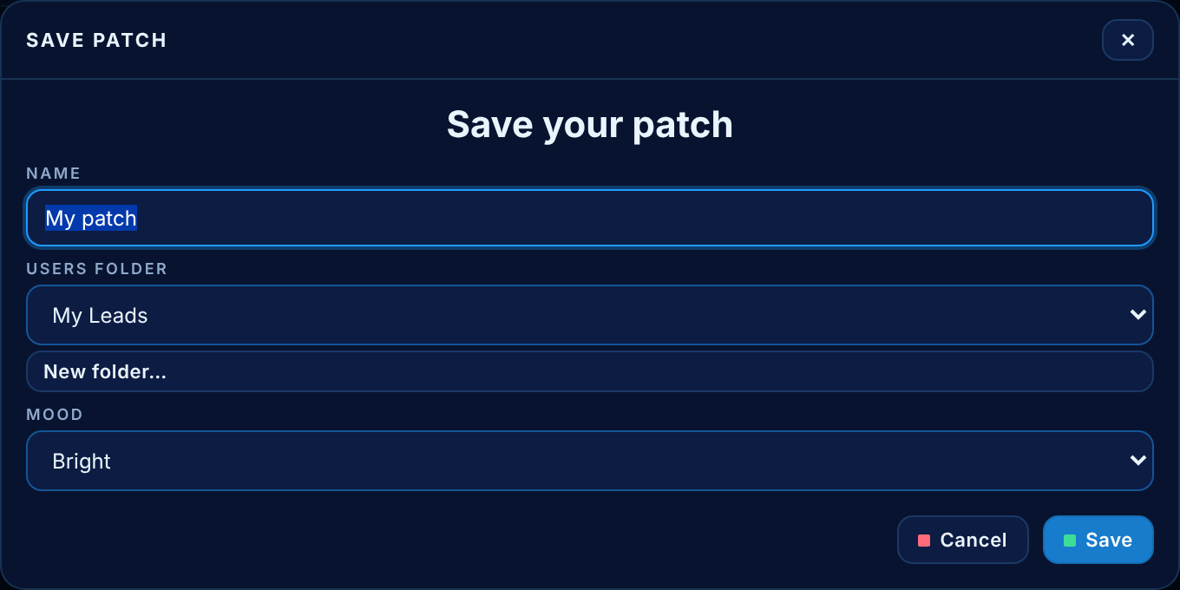
FIG 16.2 The Save dialog: name, user folder (or a new one) and mood.

Soundbanks: .nik
A .nik file is a whole bank in one file — names, categories, parameters — compressed and encrypted, ready to sell or to keep as a backup. Right-click a folder and choose Export as soundbank: one box asks for the bank's name, its author, a description, an optional cover (click the frame to choose a picture, or drop one on the window; any picture is cropped square and saved at 1024 × 1024), the password (twice), an optional legal statement — the terms the buyer must approve — and the folder the file goes to (Browse… picks it). The factory key is built in, so a folder of factory patches needs no password.
To import, click Import .nik and double-click the file, or drop a `.nik` anywhere on the window. Nikkosynth first checks that it is a Nikkosynth soundbank and says why when it is not (a NikPak archive, for instance, has the same extension). Then it shows the bank's cover, name, author and description and asks for its password; a bank with a legal statement shows the terms, and Import stays locked until you click I approve. The patches land in Users › <bank name>, with the cover and Terms of use.txt beside them. Rebuild patches resets the factory bank to its original values after a confirmation.

Mutate
Mutate (F8) is a musical nudge of the patch that is playing: tuning by a few cents, pan, cutoff, resonance, envelope times, LFO rates and effect depths, each by a little. It never touches what makes the patch that patch — the oscillator sources, the filter type, the effects chosen, the voice count — and never pushes a sound into silence. Twenty presses give a different take of the same sound; Undo goes back.

17 Wavetables
WT on any Analog or Super row opens the wavetable browser: families on the left, tables on the right. Clicking a table auditions it at once — it is loaded into the oscillator, so the next note plays it — and the browser stays open so another can be tried. Apply keeps the last one; Cancel puts the oscillator back exactly as it was. The catalogue holds 451 built-in tables, and any table you drop into your own wavetable folder (%APPDATA%\nikkosynth\wavetables) joins it.
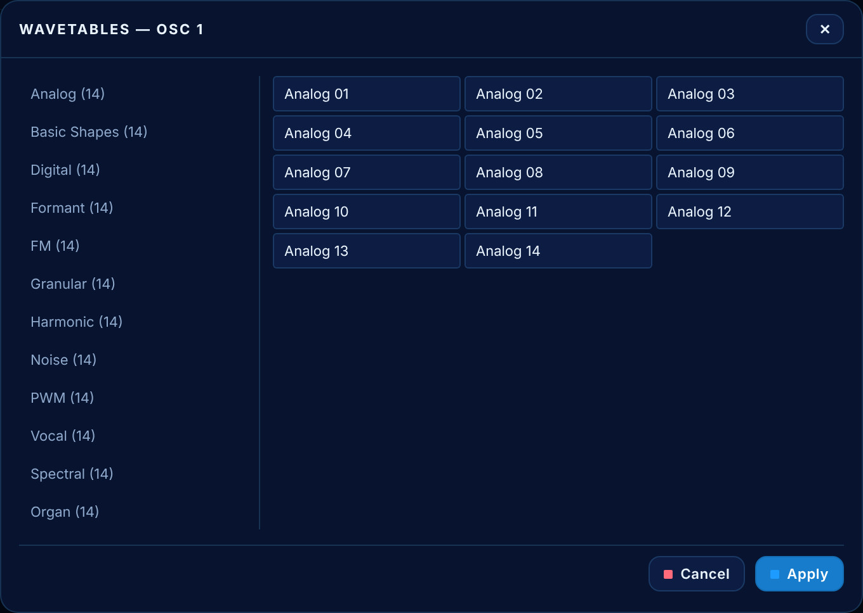
FIG 17.1 The wavetable browser for OSC 1: families on the left with their counts, tables on the right.

18 Look, language and zoom
Nikkosynth shares its skins with the other Nikkoid tools. Skins (F10) opens a live-preview gallery of 89 skins: click a swatch to see it on the panel, then Apply or Cancel. Bright / Dark (F5) flips between the Nikkoid pair.
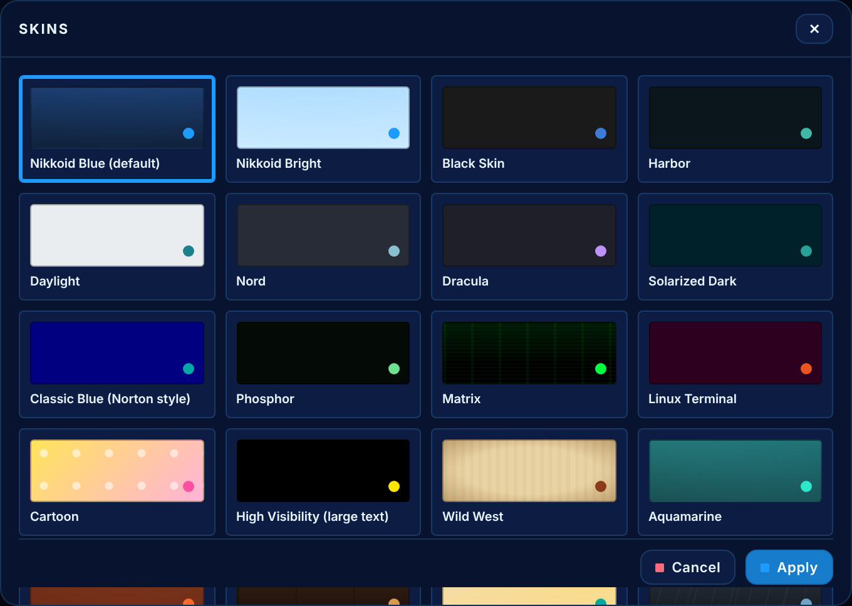
FIG 18.1 The skin gallery: each swatch shows that skin’s background, panel, accent and text.

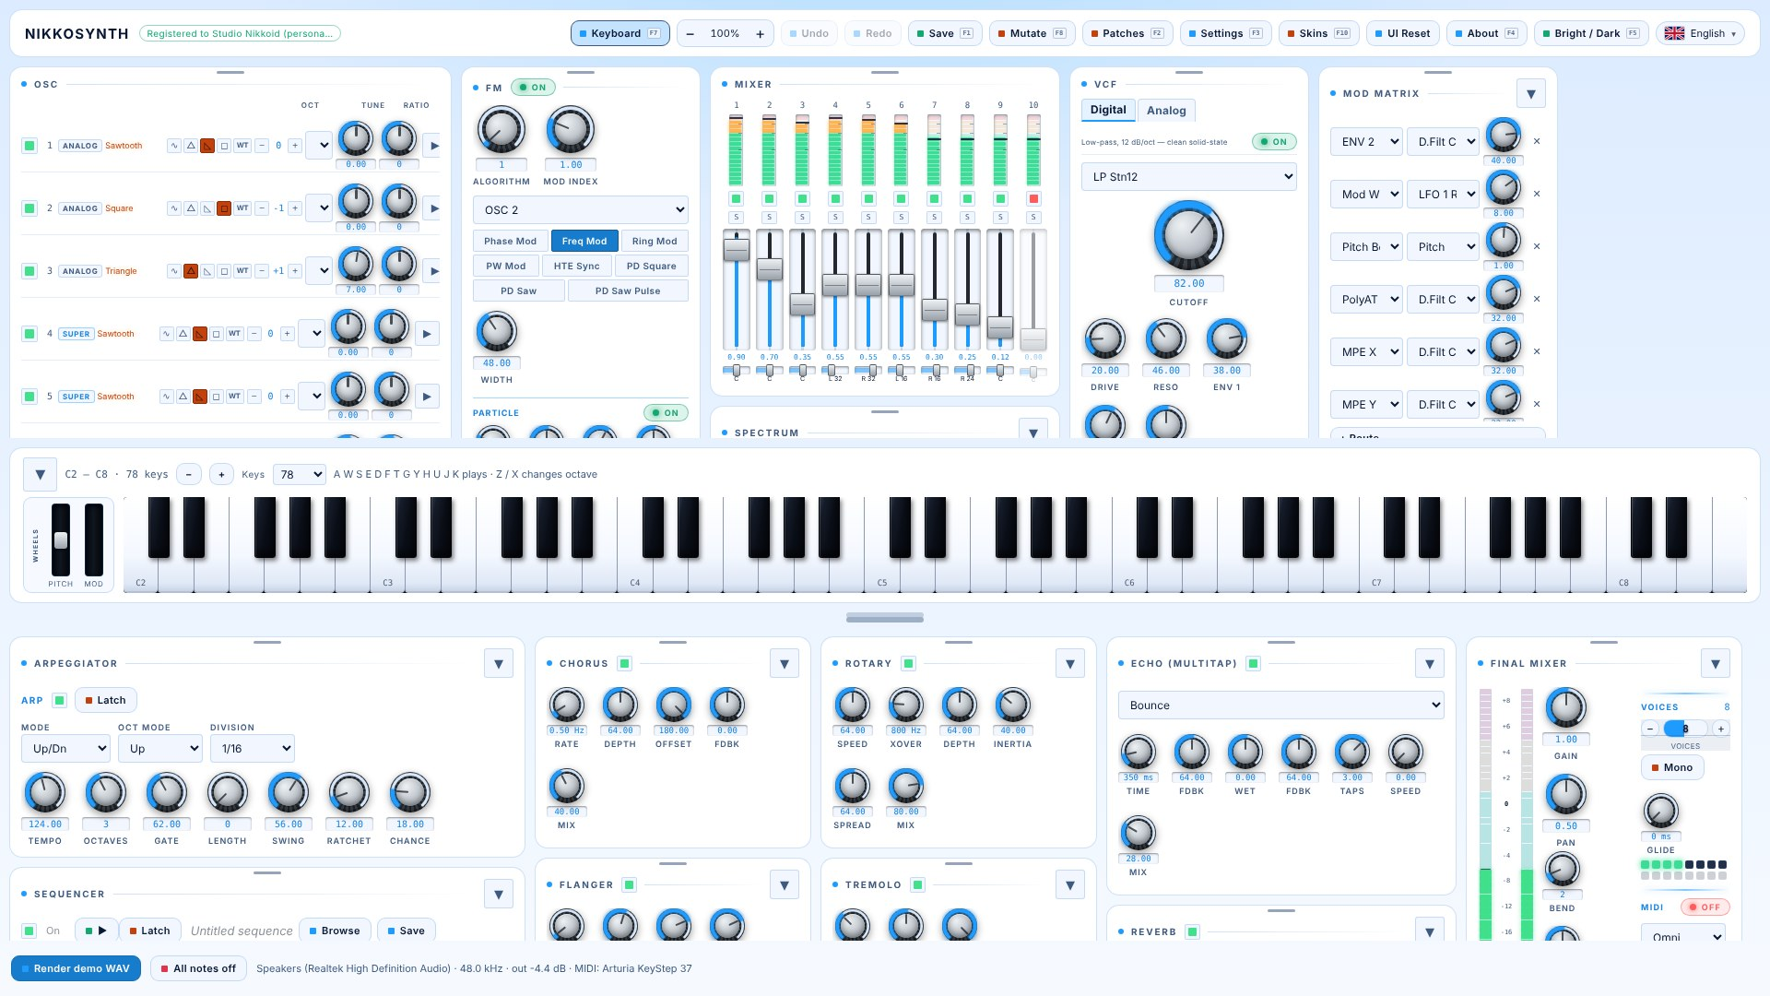 | 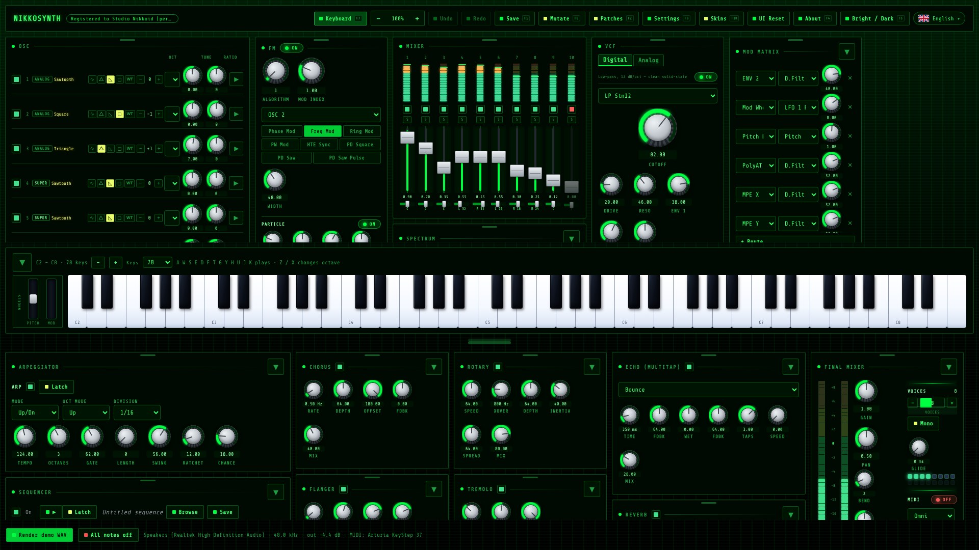
FIG 18.2 The same patch in Nikkoid Bright and in Matrix.

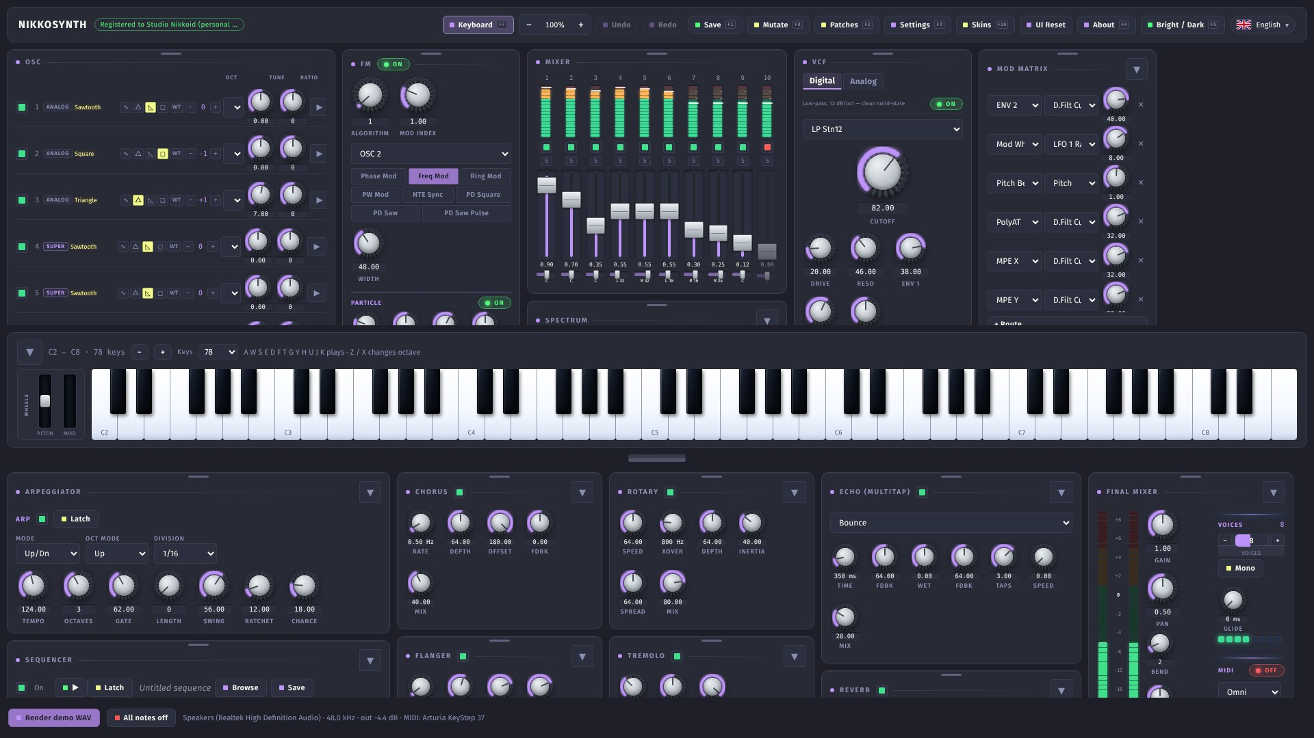 | 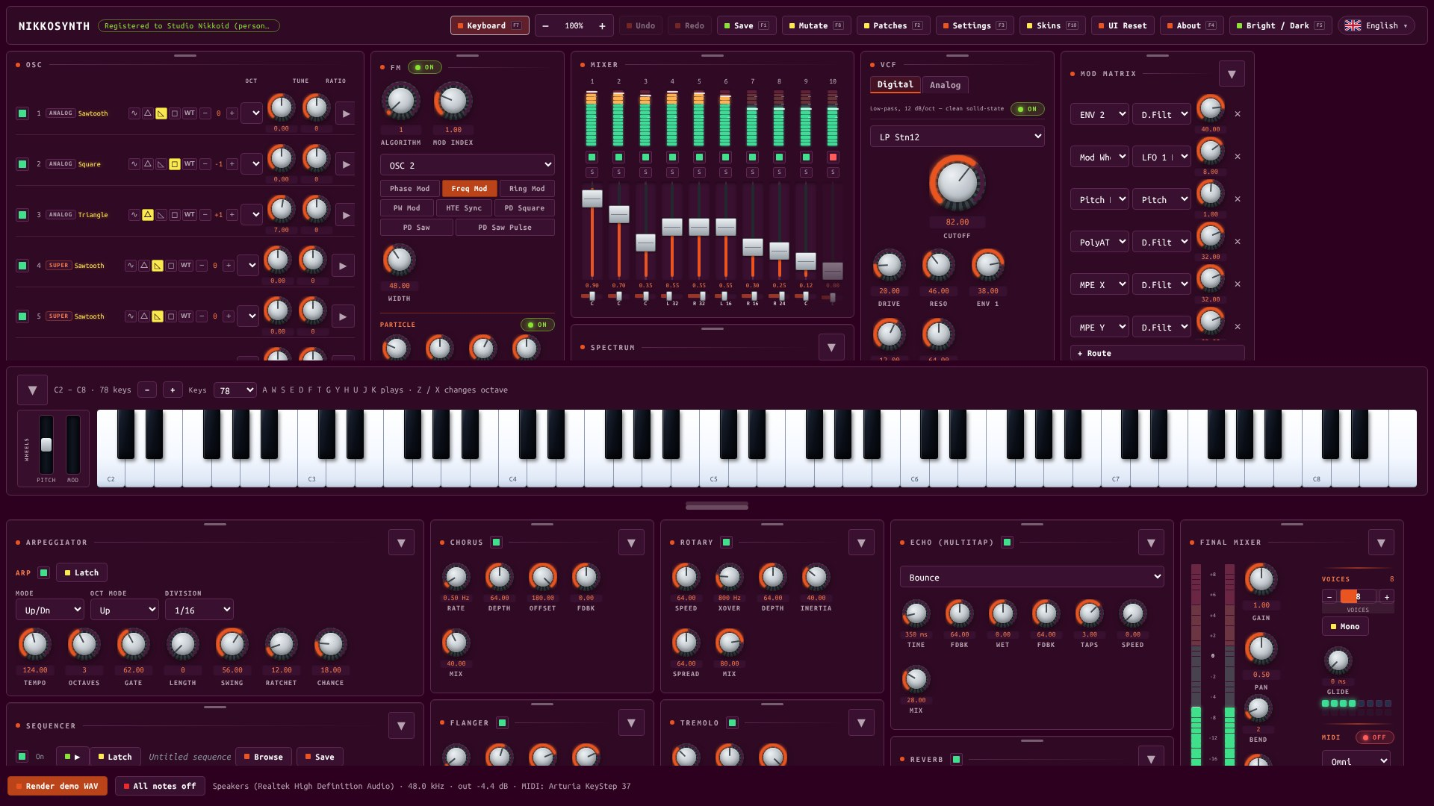
FIG 18.3 Dracula and Linux Terminal.
The whole interface zooms, not just the text — Ctrl with +, − or 0, Ctrl and the mouse wheel, or the − 100 % + control in the title bar. The layout reflows and nothing overlaps at any level. Eleven languages ship with the instrument — English, French, German, Spanish, Italian, Portuguese, Dutch, Polish, Russian, Japanese and Chinese — chosen from the flag menu.

19 Keyboard shortcuts
Function keys reach the title bar’s actions without leaving what you are doing; each is printed on its button.
KEYS | ACTION
F1 | Save the current patch
F2 | Patches
F3 | Settings
F4 | About
F5 | Bright / Dark
F6 | Register
F7 | Show or hide the keyboard
F8 | Mutate
F10 | Skins
Ctrl + Z · Ctrl + Shift + Z | Undo · Redo
Ctrl + + / − / 0 | Zoom in, out, reset
Tab | Swap the divider’s two extremes
Escape | Cancel the top-most dialog
A W S E D F T G Y H U J K | Play an octave from the computer keyboard
Z · X | Octave down · up

Shortcuts never fire while you are typing in a field and never open a dialog over another dialog.

20 Settings, licence and updates
Settings (F3) holds what is worth setting once: the audio output, the MIDI input, the tooltips switch and the soundbank password — used when an export is made without typing one, kept in memory for the session and never written to disk. Switching the audio device rebuilds the engine at the new rate and re-sends the patch; if the device disappears, the output reopens by itself.
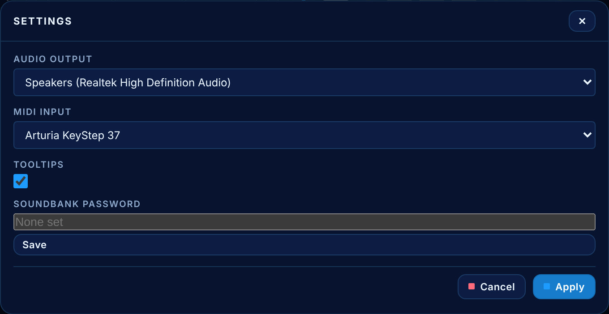
FIG 20.1 Settings: audio output, MIDI input, tooltips and the soundbank password.
The status line at the bottom reports the device, its rate, the output level and the MIDI connection. If the meters move but you hear nothing, the level tells you the instrument is producing sound and the problem is downstream — the device, the cable or the system mixer. Render demo WAV writes a short demo of the current patch to a file, and All notes off silences everything at once.
About (F4) shows the version, the licence and the registration state. Nikkosynth checks for a newer release once at launch and tells you if there is one; nothing downloads or installs itself. Registration is covered in Part III.
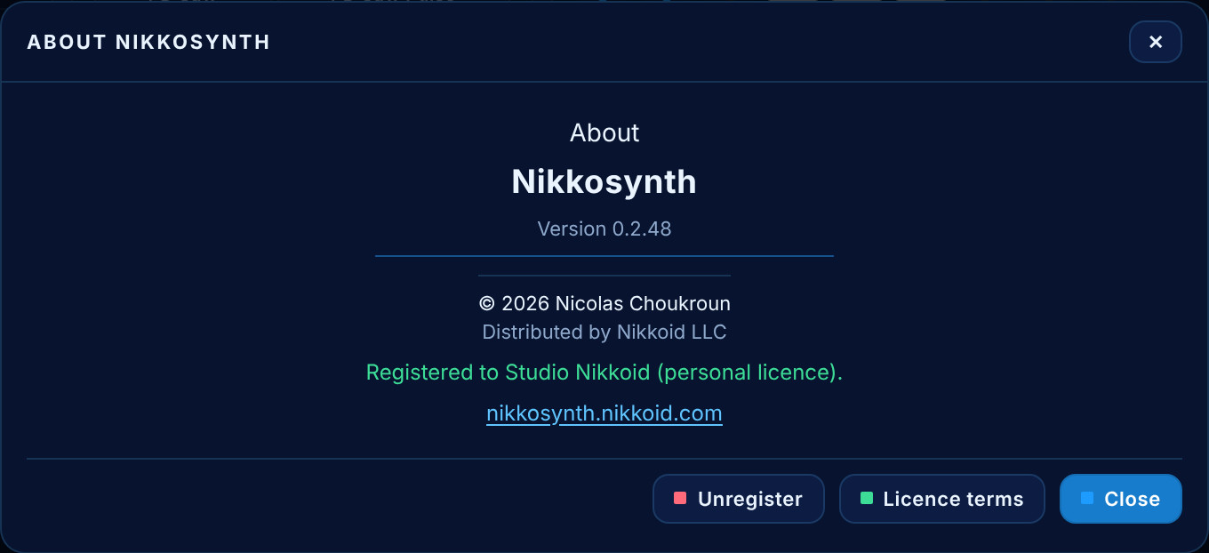
FIG 20.2 About: the version, the copyright, and the licence the copy is registered to.

21 Recipes
A handful of patches built in a few moves each, to show what the instrument is for. None needs the matrix to start — the pre-wired routes do enough to hear the idea.

A pad that sits under a voice
- On OSC 4, choose a saw. On its page set Detune to about a third and Mix to two-thirds: wide, but still one note.
- Open ENV 1 and drag the attack to about half a second and the release to two. Give the attack a positive curve — the note should arrive, not fade in.
- Close the Analog filter to about 70 and turn its ENV 2 knob up a little, so ENV 2 opens it on each note.
- Turn on the Hall reverb with a long time and a 30 % mix.

A bass with a real attack
- OSC 1 to saw, one octave down. OSC 2 to sine, two octaves down, lower — that is the sub.
- Digital filter to LP Ldr24, cutoff around 60, resonance about 30.
- ENV 2: instant attack, 200 ms decay, zero sustain. The filter drops as the note starts — that is the pluck.
- In the Final Mixer, Mono on and a short Glide for legato lines.

A DX7 electric piano
- OSC 8, and step to algorithm 5: three carriers, each with its own modulator.
- Carrier ratios at 1, modulators at 1 and 3 — that is the tine.
- Short decay, low sustain, a 400 ms release; a slow Chorus and a Plate reverb.

A filter that dips instead of opening
- Start from any pad. Give ENV 2 a slow attack and a long decay — the default route already sends it to the digital cutoff.
- On the ENV 2 tab press Invert. The cutoff now falls on each note and recovers — a swell that darkens, the trick behind the “Inverse” Pure Analog patches.

A patch that plays itself
- Load any bass or pluck and switch the Sequencer on.
- Press Browse, choose a genre and click through sequences until one fits; Keep it.
- Route Seq Mod to the digital cutoff in the matrix and draw the Mod lane: each step now opens the filter by its own amount.
- Press Play with Latch on, and play with the knobs while it runs.
The point is not that these are the best patches in the bank. It is that a pad, a bass, a DX7 piano and a sequenced line are all the same instrument, in the same window, with the same filters and effects behind them.
HOW IT IS BUILT

Part II — Technical Reference
This part describes what Nikkosynth actually is: the software it is built from, the signal path, and the algorithms behind every module — where they come from, what they compute, and the choices that were made when two answers were possible.
It is written for the person who wants to know why a patch behaves the way it does, and for the person who will modify the instrument. It is the engineering, described plainly, including the places where the implementation is an approximation rather than a model.
An instrument is a set of decisions. This part documents them.

22 Architecture
Nikkosynth is three layers, separated so that the layer that must be fast never waits for the layer that must be pretty.
LAYER | RESPONSIBILITY
The engine | A Rust crate, nikkosynth-engine: oscillators, noise, filters, envelopes, LFOs, matrix, effects, arpeggiator, sequencer, tuning and the wavetable catalogue. It knows nothing of windows or files beyond reading a table.
The application | A Tauri 2 shell. src-tauri owns the audio device, MIDI, the licence, the update check, the patch store, the factory bank and the sequence library; src is a framework-free TypeScript front end that draws the panel.
The wrapper | A JUCE plug-in build (VST3, CLAP, standalone) around the same engine crate, possible because the engine has no GUI dependency.

NOTE Why Rust for the DSP
The audio callback has a hard deadline every few milliseconds and is the one place in a music application where a pause is a click. Rust makes allocation and aliasing visible at compile time, so the hot path is written without either, and old parameter sets are handed back to a housekeeping thread to be freed rather than dropped on the audio thread.

Threading
The audio callback never touches the interface. Notes, controller changes and parameter snapshots travel down a command channel drained at the top of every buffer, so the callback stays lock-free and allocation-free. The interface reads meters, voice LEDs and the analyser through one short meters poll. MIDI runs on its own thread with a watchdog that reconnects a keyboard plugged in after launch. The factory bank is built at launch in the background, and rebuilt whenever its folder is empty.

Sample rate
The sample rate is a runtime value throughout. Every oscillator, filter, envelope, LFO, delay line and reverb is built against the device’s rate, so nothing is mistuned on 44.1, 48 or 96 kHz, or in a host that changes rate mid-session.

23 The signal path
The order of the modules is the order of the sound.
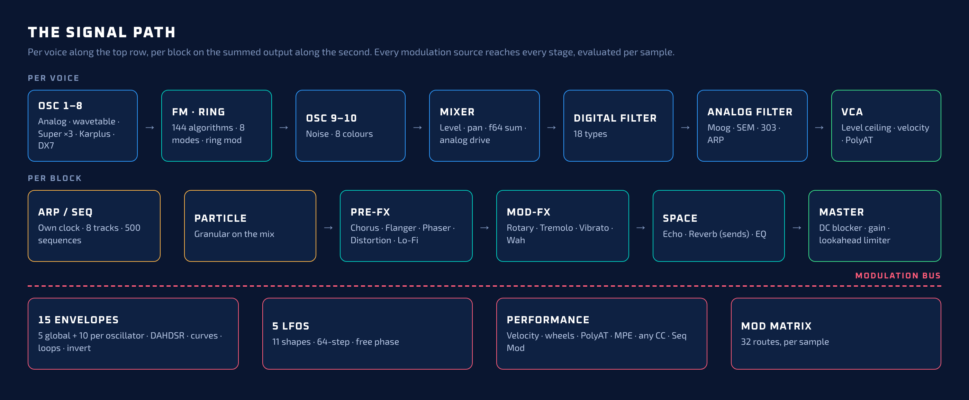
FIG 23.1 The Nikkosynth signal path: per voice along the top, per block on the summed output below, and the modulation bus that reaches every stage.

Per voice
- Eight tone oscillators produce samples, each with its own pitch, level, pan and — where relevant — its own physical-model or FM engine. Microtuning is applied once, at note-on.
- The FM bank applies the modulators to the carriers according to the algorithm and the modes. The special oscillators (Super, Karplus, DX7) are complete voices: they are always summed and never act as modulators.
- Two noise oscillators add their colours beside the tone oscillators. Noise is a spectrum, not a pitch, so they never join the carrier bank.
- The mixer applies each channel’s level and equal-power pan and accumulates the ten in double precision (f64), converting once after the mix, so a quiet noise bed under a full-scale saw keeps its detail.
- Analog drive, then the Digital filter and the Analog filter in series, one instance per side, then the VCA.

Per block
- Voices are summed, including any voice fading after a steal.
- Particle granulates the summed mix.
- The effects run in strip order: Chorus, Flanger, Phaser, Distortion, Lo-Fi; Rotary, Tremolo, Vibrato, Wah; Echo and Reverb as sends; EQ.
- The master bus: a 5 Hz DC blocker, the Final Mixer gain, and the lookahead limiter, which also reports the peak for the meters.

Timing
Envelopes, LFOs and the whole matrix are evaluated per sample, not per block. That costs arithmetic and buys exactness: a routed envelope has no staircase, an audio-rate LFO is possible, and a fast modulation on a short note is not quantised to a buffer boundary.

24 The oscillator engine
Every oscillator, of every type, is band-limited. This is the least visible decision in the instrument and the one that most affects whether it sounds like a musical instrument or like a computer.

Why band-limiting is not optional
A naive sawtooth contains every harmonic, including those above half the sample rate. They fold back into the audible range as partials out of tune with the note. Three octaves up it is the difference between a saw and a hiss.

The mip-map solution
Each waveform is stored as a pyramid of single-cycle tables, one per half-octave of pitch, each holding only the harmonics that fit below Nyquist at the top of its band. The oscillator picks the level from its own phase increment — the pitch it is actually playing, modulation included — and caches it until the increment moves by more than one percent. Tables are synthesised by one inverse FFT per level. Pulse width needs no tables: a pulse of width w is a saw minus the same saw shifted by w.
Measured: at A7 the 13th-harmonic alias of a naive ramp is 7.7 % of the fundamental. Band-limited, it is 0.029 %. Sines come from a 4,096-point table with an error near −130 dB.

Wavetables
A wavetable is a stack of single-cycle frames of 2,048 samples. Each table is rebuilt as its own pyramid when it loads, scanning between frames is bilinear, and the scan position is a matrix destination. Patches store a table by name, so a patch finds its table again after the catalogue grows.

The oscillator modes
Eight modes decide how a modulator affects its carrier: phase, frequency, ring, pulse-width, hard sync, and three phase-distortion variants. Hard sync resets the carrier on the modulator’s rising edge; pulse-width re-samples a square carrier with a swept duty; phase distortion warps the rate at which the carrier walks its cycle.

25 The Super oscillator
The super-saw is a specific sound with specific behaviour. Nikkosynth implements it from measurement rather than folklore, then generalises it to any waveform.
- Seven copies, unevenly detuned: at full width the partials sit at ±0.110, ±0.0629 and ±0.0195 of the fundamental (Adam Szabo, How to Emulate the Super Saw, KTH, 2010).
- The detune knob is not linear. It barely moves until halfway, then opens steeply; Szabo’s eleventh-degree polynomial is evaluated directly.
- Mix fades the centre while the copies swell: the centre falls on a line, the copies rise on a parabola.
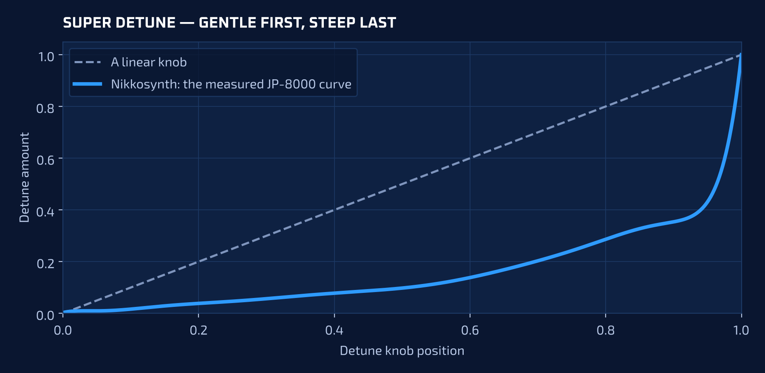
FIG 25.1 The measured detune curve against a linear knob. The gentle first half gives the control its usable range.
The output carries a high-pass at the note’s own fundamental, and the copies are free-running — every note-on assigns new phases, so repeated notes are never identical and no attack starts with a click of seven aligned waves. Because the copies sample whatever the oscillator holds, the same code gives a super-square, a super-sine or a super-wavetable. Detuned copies add in power, not amplitude, so the stack uses the measured gain curves and a fixed trim; a test holds the level within a factor of 1.7 across the Mix range.

26 Karplus-Strong and the DX7

Strings: Guitar and Piano
A delay line with a filter in its loop. The period is exact (fractional read), a one-pole damping filter sets how fast the highs die, the loop gain is computed from the decay time as a −60 dB fall, and all-pass dispersion stretches the upper harmonics sharp as a stiff string does. The piano adds a raised-cosine hammer and a second string a few cents away.

Struck bodies: Metal and Glass
A struck bar is not a string. Metal and Glass are modal banks at the measured ratios of a free bar (1 : 2.76 : 5.40 : 8.93 : 13.34) and a bowl (1 : 2.32 : 4.25 : 6.63 : 9.38 : 12.40), plus a few milliseconds of strike. A test fails if any two materials render the same thing.

The DX7 oscillator
Six sine operators and the thirty-two published algorithms, stored as data: for each, the operator pairs that modulate and the one that feeds back. An operator that is never a modulator is a carrier; that one rule derives both the sound and the diagram on the page. Each operator’s phase advances once per sample and the sum of its modulators is added before the sine is taken — modulation is a phase offset, which is why timbre brightens with depth and pitch does not move.
NOTE Two faults worth recording
The first version computed each operator’s modulation and never applied it, so the thirty-two algorithms were thirty-two ways of choosing sines; the second advanced the phase inside a convergence loop, so every note played a twelfth sharp. Both were found by measurement — a sideband test and a zero-crossing count — and both are now regression tests.

The FM algorithm bank
Beyond OSC 8, the ordinary oscillators share 144 FM algorithms: which act as carriers and which as modulators. Algorithm 001 has every oscillator as a carrier and is where every patch starts; a patch that wants FM asks for it.

27 Noise
OSC 9 and 10 generate noise per voice. White is a uniform generator; pink is a Voss-McCartney-style bank; brown is a leaky integrator bounded by its own leak rather than a clamp; grey follows an inverse equal-loudness curve; blue and violet are differentiated white. Velvet and crackle are sparse impulse trains whose grains decay in about 110 and 35 samples, so they rattle instead of hiss. The six continuous colours are trimmed to the same RMS — the trims are the mean over eight seeds, because the filtered colours vary a few percent from seed to seed — while velvet and crackle stay deliberately quieter.

28 The filters

The digital filter
Eighteen models on a state-variable core using the topology-preserving transform, numerically stable at any cutoff and resonance. The families differ in pole count, resonance law and drive. The Vowel type replaces the response with three formant band-passes; the knob position chooses the vowel (13 A, 38 E, 64 I, 90 O, 108 U) and a 24× make-up is applied where the loss happens.

The analog filter: four circuits
CIRCUIT | MODEL
MINI | A transistor ladder: four one-poles with a tanh in each stage, global feedback and 2× oversampling. Loses bass as resonance rises and self-oscillates — both by design.
SEM | A state-variable filter with a cubic soft-clip in its feedback, which is where its smooth resonance comes from.
ACID | A low one-pole high-pass into a sharp resonant core, its peak near +13 dB at full resonance.
ARP | Two cascaded two-pole sections with their own local feedback rather than one four-pole ladder.

NOTE The trap that cost the most time
The ARP first modelled as a ladder with different coefficients measured within 0.0016 of the MINI across a sweep. A filter is a topology, not a set of numbers; a test now compares every pair of circuits.

- The ladder’s feedback comes from the solved loop, not the previous output — otherwise the peak lands an octave low.
- The one-pole coefficient is 1 − exp(−2π fc/sr); an SVF needs g = tan(π fc/sr). Mixing them moves the corner and makes the resonance seem to vanish.

29 Envelopes, LFOs and the matrix

Envelopes
An envelope is a small state machine with a counter per stage, so a zero-length stage is skipped instantly. Attack, decay and release are shaped by a warp on the normalised progress, and the same function draws the curve on screen. A loop is a jump back to the start of its range with a counter loaded at trigger. Invert produces two outputs: the amplitude path always reads the envelope upright, the modulation path reads 1 − level — which is why ENV 1 can be inverted for the filter while the note still sounds. At a velocity amount of zero the response is unity, as the reference manual specifies.

LFOs
A Step LFO is an oscillator whose output is the current step’s value; Semi Lock quantises to semitones and Smooth applies a one-pole slew. With Trig Sync off an LFO never resets on a note. Every note starts at the LFO’s Phase plus a random offset, and chorus, flanger, phaser, tremolo, vibrato, wah and rotary also start their sweep anywhere, so a moving stereo sound never begins hard on one side.

The matrix
Thirty-two slots evaluated per sample. Depths are in the destination’s own units. Six routes live inside their modules instead of the matrix — ENV 1 and LFO 1 to the digital filter, ENV 2 and LFO 2 to the analog filter, LFO 3 to the amplifier, and ENV 1 to the level — so all thirty-two slots stay free. Every MIDI CC is fed to the voices, so any controller can be routed without a hard-coded map.

30 Arpeggiator, sequencer and tuning
The arpeggiator and the sequencer share one tempo but have their own clocks. The sequencer advances each of its eight tracks by its own length (polymeter); a ratchet spreads its repeats across the step after its nudge, and the step’s velocity is the note’s velocity. Mono keeps a held-note stack for last-note priority and legato; Glide slews the pitch in both mono and poly.
The sequence library is generated in code from a per-genre profile — division and swing, scale, known rhythms, the kind of line (bass, arpeggio, lead or stab), the use of gate, ratchets, micro-timing and chance, a counter line and, where the style has one, a polymetric third track. It is deterministic: the same 500 sequences on every machine.
Microtuning is an octave-repeating twelve-note table applied once per note at note-on (engine/src/tuning.rs), so transpose and detune still work on top. Tests check Just’s pure thirds and fifths, Meantone’s pure thirds and the root wrap.

31 The effects
The order changes the sound more than the individual effects do: an echo into a reverb is a space, a reverb into an echo is a smear.

Modulation and colour
Chorus and flanger are modulated delays differing in length and feedback; each keeps two delay lines so the stereo channels never cross. The Phaser is 2–12 first-order all-pass stages swept exponentially between 160 Hz and 5.2 kHz with feedback up to ±63; its coefficients update every 32 samples to avoid a tan per sample. Lo-Fi is a phase-accumulated sample-and-hold (any rate from 500 Hz to 48 kHz, sweepable), a 1–16-bit quantiser and a 12 dB/oct tone filter. Rotary has separate horn and drum paths with inertia; Wah is a resonant band-pass swept by an LFO or the pedal.

Echo and reverb
The echo is a multitap delay with up to four taps, separate damping per channel, and Bounce or Sweep panning. The reverb is a pre-delay, early reflections and a four-stage diffuser into either a comb bank (Plate) or an eight-line feedback delay network with a Householder matrix and per-line damping. Shimmer pitch-shifts its feedback up an octave and a fifth. Both are sends: they add their tail to the dry signal rather than crossfading it away.
NOTE The shimmer latch
The shimmer’s feedback was meant to be high-passed then low-passed, but both filters were the same low-pass, so DC went round the loop untouched at a gain of 1.5. On a 12–20 s tail it latched onto a constant level — nine of ten Evolving pads stopped crossing zero after five seconds. The high-pass is now the input minus its lows, the loop gain is 0.8, and a test renders 6, 14 and 20 s tails with silence after.

EQ, Particle and the master
The EQ is five RBJ-cookbook biquads in transposed direct form II, rebuilt once per block when a knob moves, and bit-transparent when flat. Particle keeps a quarter-second ring buffer and a pool of Hann-windowed grains. The Analog drive is followed by an automatic make-up gain averaged over about 30 ms and a brickwall at full scale, so it adds harmonics without adding level. The master runs a 5 Hz one-pole DC blocker, the gain, and a 3 ms lookahead limiter (−1 dBFS ceiling, 80 ms release); the lookahead means the first ~132 samples of any render are silent.

32 Files and formats

.nikkosynth — a patch
Plain UTF-8, one key = value per line, with the parameter block as a single JSON line owned by the front end. Every field is flattened to one line on write, so a line break in a name cannot inject a key. Delete, move and load accept only .nikkosynth files inside the patch store.

.nik — a soundbank
A whole bank in one file. The bank is deflated, then encrypted as one stream; only a small header (bank name, count, author, description, salt, nonce and, when present, the legal statement and the cover picture) is readable. The header is covered by the tag, so the terms and the cover cannot be edited or removed without the bank failing to open, and the import refuses a bank whose terms were not approved word for word. A bank with terms is container version 2, which an older Nikkosynth refuses rather than importing it without showing them. The key is SHA-256 iterated 20,000 times over the salt and password, the keystream is a SHA-256 counter stream, and a tag over the ciphertext rejects a wrong password and a tampered file alike. Decompression is capped at 512 MB, and names from the bank go through a filter that refuses path climbing and Windows device names.

Where things are stored
Everything the application writes lives in the per-user data folder (%APPDATA%\nikkosynth on Windows): patches/factory, patches/Users/<folder>, patches/sequences/<genre> and wavetables.

.hydra
The .hydra bank format is decoded — its structure and category byte are understood — but the mapping from its parameter words to named parameters is not published. Rather than import a thousand patches that would all sound like the default, the importer refuses, and the browser lists only patches that play.

33 How this was verified
LEVEL | WHAT IT PROVES
Engine tests | Every DSP module is tested against a measurement: a filter attenuates above its cutoff, a ladder peaks where its knob says, a wavetable ladder is band-limited at every level, the four circuits differ, a long shimmer neither latches nor runs away, the master blocks DC.
Control coverage | Every panel control is set through the path the interface uses, and the audio must change. A knob that does nothing fails the build.
Bank tests | The 2,000 patches have unique names, every switched-on oscillator is heard, FM is off unless asked for, every heard oscillator sits on an octave, loudness is comparable (with a rendered report), the kit balances within 9 dB of the kick, the Evolving pads move and no two alike.

At this edition that is 202 engine tests and 116 application tests, plus a type-check of the whole front end, all green. Numbers like these are not a guarantee; they are an honest statement of what would break loudly instead of quietly.

What is not finished
Documented in the reference instrument and not in this build: envelope BPM sync and the four trigger sources; arpeggiator Entropy Shuffle, the phrase library, Tap Rhythm and Step Offset; a compressor; the five named delay types; macros; Multi mode; and the .hydra sound mapping. None is simulated by a control that does nothing.

34 Why one instrument is enough
A subtractive patch, a wavetable patch, a super-saw stack, a physical string, a six-operator FM tone and a noise bed are all driven by the same fifteen envelopes, five LFOs and thirty-two-slot matrix, played by the same arpeggiator and sequencer, and finished by the same twelve effects. On a desk of five instruments, the moment you want an envelope from one to shape the filter of another, you are back to cables. Here it is a route.
The test of a synth is not what it can do once. It is whether the tenth patch you make is as good as the first, and whether you still have a reason to open anything else.
QUICK LOOKUP

Appendix A — Parameter reference
Every control and its range. Ranges are in the units the panel shows: 0…128 for most parameters, ±64 for depths and amounts, seconds or hertz where the label says so.

A.1 Global conventions
TERM | MEANING
Control units | Most parameters are 0…128. Cutoff maps logarithmically: 64 is about 1.5 kHz, 128 is 20 kHz.
Amounts | ±64; zero means no response for velocity and no depth for a route.
Levels | Against unity, 64 is unity and 128 double (Patch Level, D.Filt Level).
Keytrack | ±200 %, 100 % = one-for-one. Anchored on C2 for the filters.

A.2 Oscillators
CONTROL | RANGE | WHAT IT DOES
Initial Level | 0…128 (128) | Where the oscillator starts.
ENV Level | ±128 (0) | How far the envelope moves it.
ENV Source | Self · Env 1 · 2 · 3 | Which envelope shapes the level.
Invert | off · on | Waveform polarity.
Velocity · PolyAT | ±64 (0) | Sensitivity of Initial Level.
Feedback · Phase | 0…100 · 0…360° | Analog oscillators.
Keytrack | ±200 % (100 %) | Pitch tracking.
Oct · Tune · Ratio | −4…+4 · ±100 ct · S/R/F | Pitch.
Super Detune · Mix | 0…1 | Seven-copy width and balance.
Karplus | Material · Damping · Bright · Disperse · Decay | Guitar, Piano, Metal, Glass.
DX7 | Algorithm 1…32 · Feedback · Decay · R1…R6 | Six-operator FM.
Noise colour | White · Pink · Brown · Grey · Blue · Violet · Velvet · Crackle | OSC 9 and 10.

A.3 Filters and VCA
CONTROL | RANGE | WHAT IT DOES
Digital type | 18 models | SEM LP-BP-HP, LP-NO-HP; HP MS20, 3-Ler, Stn12; BP 3-Ler, Stn12; LP Ldr12, Ldr24, Fat12, Fat24, Gate, MS20, 3-Ler, Stn12, 1Pole, 8Pole; Vowel.
Cutoff · Reso | 0…128 | Both filters.
Drive / Morph | 0…128 | Digital; Pre / Post.
ENV · LFO amounts | ±64 | ENV 1 / LFO 1 digital, ENV 2 / LFO 2 analog.
Analog circuit | MINI · SEM · ACID · ARP | Four topologies.
Pre-Drive | 0…128 (16) | Analog input saturation.
VCA | OSCs · D.Filt · VCA · Patch Level, LFO 3, Velocity > ENV, PolyAT, Initial | See Chapter 7.

A.4 Envelopes and LFOs
CONTROL | RANGE | WHAT IT DOES
Delay … Release | time | DAHDSR; zero skips a stage.
Sustain | 0…128 (shown in dB) | Resting level.
Attack / Decay / Release curve | ±64 | Exponential, linear or logarithmic.
Quantize | 0…128 | Steps the output.
Env Loop · Stage Loop | off · 2…50 · inf; D>A · D>H · D>D | Repeats.
Legato · Reset · Freerun · Invert | off · on | Trigger behaviour; Invert affects modulation only.
LFO shape | 11 | Sine, Triangle, Saw Up, Saw Down, Square, Pulse 27 %, Pulse 13 %, S&H, Noise, Random, Step.
LFO Rate · Delay · Fade In · Phase | Hz or BPM · 0…60 s · 0…600 s · 0…360° | Timing.
Trig Sync | Poly · Single · Off | Per note, shared, free.

A.5 Matrix
GROUP | MEMBERS
Sources | ENV 1–5 · OSC 1–10 Env · LFO 1–5 and 1+–5+ · Velocity · Keytrack · Note · PolyAT · MonoAT · Mod Wheel · Pitch Bend · Exp · Sustain · MPE X / Y / Y+ · Voice Mod · CC 0–127 · Constant · Seq Mod
Per oscillator | Initial · Env Level · Level · Ratio · Feedback · Width · Detune (4–6) · Pan; OSC 9/10 levels
Filters | Cutoff · Reso · Morph · Drive · ENV / LFO amounts · Level (digital); Cutoff · Reso · Pre-Drive · ENV / LFO amounts (analog)
Other | Ring · VCA Level · LFO 3 Amt · LFO 1–5 Rate and Level · Output Level · Pan · Wave Scan

A.6 Arpeggiator, sequencer and Final Mixer
CONTROL | RANGE | WHAT IT DOES
Arp Division · Mode · Oct Mode | 18 · 9 · 6 | Note value, pattern, octave expansion.
Octaves · Gate · Tempo | 1…6 · 5…150 % · 30…240
Swing · Ratchet · Chance · Latch |  | Feel and probability.
Seq tracks · steps | 8 · 1…64 each | Polymeter.
Seq lanes | Note · Velocity · Gate · Chance · Ratchet · Nudge · Mod | Per step.
Seq Division · Swing · Direction | 18 · 25…75 · Fwd/Back/Ping-pong/Random | Own clock.
Voices · Mono · Glide | 1…16 · off/on · time | Polyphony and portamento.
Bend · Global Pitch | semitones · ±24
Tuning · Root | Equal, Just, Pythagorean, Meantone, Werckmeister III, Rast, Custom · C…B | Microtuning.

A.7 Effects
EFFECT | CONTROLS
Chorus · Flanger | Rate · Depth · Offset · Feedback · Mix
Phaser | Rate · Depth · Offset · Feedback · Stages (2–12) · Mix
Distortion | Drive · Tone · Asym · Curve · Out · Mix
Lo-Fi | Bits (1–16) · Rate (0.5–48 kHz) · Tone · Mix
Rotary | Speed · Crossover · Depth · Inertia · Spread · Mix
Tremolo · Vibrato | Rate · Depth · Mix
Wah | Mode · Rate · Depth · Cutoff · Q · Mix
Echo | Pan (Off/Bounce/Sweep) · Time · Feedback · Wet tone · Feedback tone · Taps (1–4) · Speed · Mix
Reverb | Type (Room/Hall/Plate/Chamber/Shimmer) · Pre · Time · Size · Diff · Dens · Early · Mod · Rate · Width · Tone · Hi Damp · Lo Cut · Mix
EQ | Low shelf · 3 peaks · High shelf (gain, frequency, Q) · Mix
Particle | Mix · Size · Density · Spread · Pitch

THE FINE PRINT, PLAINLY

Part III — Licence, Updates and Copyright
Nikkosynth costs $89 for an individual. Before you pay anything it works completely and without a time limit, so the decision follows the playing rather than the other way round.

35 How the licence works
Nikkosynth is not crippled, time-limited or watermarked. Before you register it plays, saves and uses every module; the only differences are the reminder in the title bar and a registration box at launch, which Test for free dismisses.
A licence is a key you paste into the registration box with the name and e-mail it was issued to. It is checked entirely offline: no server, no connection, no account.

What is inside a key
An Ed25519 signature over your name, e-mail, licence type and seat count, written as 108 Crockford base32 characters after the prefix NSY1-. The instrument holds only the public key: it can verify a licence but cannot create one. The name and e-mail must match, because they are part of what was signed.

Personal and company licences
LICENCE | TERMS
Personal | $89. One person, any number of their own computers, for life — no subscription.
Company | Per seat, in tiers that fall as the count rises: $89, $79 from 10 seats, $69 from 25, $59 from 50, $49 from 100. A key file next to the executable deploys it without typing on each machine.

The registration box
Register (F6), or the chip in the title bar, opens it. Enter the name and e-mail, paste the key, press Register. If a key is refused, the cause is almost always a different e-mail address, or a key altered by a word processor’s smart quotes — paste it as plain text.
NOTE Refunds and revoked keys
A revoked key is refused by every build after the revocation, because the block list is compiled into the instrument rather than fetched. Revocation is for refunded and publicly posted keys only.

36 Updates
Once at launch, Nikkosynth makes one small request to nikkosynth.nikkoid.com/version.json (four-second timeout, 64 KB cap) and compares versions numerically. If a newer release exists, About offers it with the release notes and a Download button that opens the download page. Nothing is downloaded, installed or replaced without you doing it, and a failed check says nothing. Every delivered build gets a new number, and the website’s changelog is the repository’s.

37 Credits and third-party material
Nikkosynth is an original work: its DSP is written for it, its factory bank and sequence library are generated by it, and no data from another manufacturer’s product is included.
COMPONENT | SOURCE
Super Saw | Adam Szabo, How to Emulate the Super Saw, KTH Royal Institute of Technology, 2010. Detune curve, offsets and mix curves as published.
Analogue filters | Huovilainen’s nonlinear ladder, Zavalishin’s topology-preserving transform, and the Faust vaeffects library as a description of the structures.
EQ | Robert Bristow-Johnson, Audio EQ Cookbook.
DX7 algorithms | The routing of the thirty-two algorithms is a published fact of the original instrument, reproduced as data. No Yamaha code or data is used.
Rotary and wah | The DAFx-02 rotating-speaker model; a state-variable band-pass for the wah.
Tunings | The standard historical temperaments (Just, Pythagorean, ¼-comma Meantone, Werckmeister III) and the Rast maqam.

NOTE What was deliberately not used
One reverb and morphing-filter library was rejected because its AGPL licence is incompatible with shareware; its ideas were read and the implementation written independently. The spectrum analyser was rewritten in-house for the same reason.

Software and fonts
Built with Rust and Tauri, with a TypeScript front end. Fonts are self-hosted under the SIL Open Font Licence; their licences sit in the application’s font folder. This manual is set in Oxanium, Exo 2 and JetBrains Mono.

38 Copyright and terms
Copyright © 2026 Nikkoid LLC. All rights reserved. Nikkosynth and the Nikkoid name and logo are trademarks of Nikkoid LLC. Other product names are the property of their owners and are used only to describe the instrument an algorithm is modelled on.

Licence to use
A licence grants the named licensee the non-exclusive right to install and use the software on the computers its type permits, and to create, perform and commercially exploit music with it without further payment or credit. It does not grant the right to redistribute the software, to transfer a licence separately from it, to reverse-engineer it to build a competing product, or to remove the copyright notices.

Ownership of what you make
Everything you create — patches, sequences, recordings, performances — belongs to you. No patch is uploaded anywhere. The factory bank and sequence library are for making music with, not for redistribution as a library.

Warranty and liability
The software is provided “as is”, without warranty of any kind, express or implied, including merchantability, fitness for a particular purpose and non-infringement. In no event shall the authors or copyright holders be liable for any claim, damages or other liability arising from the software or its use. In plain terms: it is a musical instrument; if it does not work on your machine, contact support and it will be fixed.

This document
This manual may be copied and distributed in its complete, unmodified form alongside the software. It may not be sold separately, nor modified and redistributed without written permission from Nikkoid LLC.

Designed, engineered and built by Nicolas Choukroun at Nikkoid LLC.
nikkosynth.nikkoid.com
Edition of 3 November 2026 · build 0.2.47 and the next release
Copyright © 2026 Nikkoid LLC. All rights reserved.

